**A PROJECT ON**



**Optimizing Case Management with AWS: A Cloud-Powered e-Portal Solution**



**Submitted in partial fulfillment of the requirement for the award of the degree of**

**BACHELOR OF TECHNOLOGY**

**IN**

**COMPUTER SCIENCE & ENGINEERING**

**Submitted by:**

**Amaan Khan** **2016612**

**Animesh Kumar** **2016636**

**Akshat Agarwal** **2016604**

***Under the Guidance of***

**Dr. Sachin Sharma**

**(Professor)**

**Project Team ID: MP23CSE105**



**Department of Computer Science and Engineering**

**Graphic Era (Deemed to be University)**

**Dehradun, Uttarakhand**

**June-2024**



**CANDIDATE’S DECLARATION**

I/We hereby certify that the work is being presented in the Project Report entitled **“Optimizing Case Management with AWS: A Cloud-Powered e-Portal Solution”** in partial fulfillment of the requirements for the award of the Degree of Bachelor of Technology in Computer Science and Engineering and submitted to the Department of Computer Science and Engineering of the Graphic Era (Deemed to be University), Dehradun is an authentic record of my work carried out during a period from **August-2023 to May-2024** under the supervision of **Dr. Sachin Sharma**, **Professor**, Department of Computer Science and Engineering, Graphic Era (Deemed to be University).

The matter presented in this dissertation has not been submitted by me/us for the award of any other degree of this or any other Institute/University.

Amaan Khan 2016612 **signature**

Animesh Kumar 2016636 **signature**

Akshat Agarwal 2016604 **signature**

This is to certify that the above statement made by the candidate is correct to the best of our knowledge.

**Signature** **Signature**

**Supervisor** **Head of the Department**

**External Viva**

**Name of the Examiners: Signature with Date**

1.

2.

**Abstract**

The Indian legal system faces many challenges in efficiently managing court cases. The current processes involve a lot of paperwork, manual effort, and delays. This leads to slow processing of cases and difficulties for people accessing the legal system.

To help solve these issues, this project aims to build a web portal using cloud computing technology. The portal will digitize and streamline the case management process. It will have features like dashboards for lawyers, clients, courts and judges to track and manage cases online.

The project has completed the phases of requirements analysis, system design, UI mockups, implementation of the website frontend and backend, also added the feature of video conferencing and finally hosted the portal on the AWS cloud platform.

By digitizing case management through this cloud-based portal, the project aims to make the legal process more efficient, transparent and accessible to all. This can help in reducing delays and improving the delivery of justice.

**Keywords:** Legal Case Management, Cloud Computing, Web Portal, Digital Transformation, Accessible Justice

**Acknowledgement**

Any achievement, be it scholastic or otherwise, does not depend solely on individual effort but on the guidance, encouragement, and cooperation of intellectuals, elders, and friends. Several personalities in their capacity have helped me in carrying out this project work.

Our sincere thanks to project guide **Dr. Sachin Sharma,** Department of Computer Science and Engineering, Graphic Era (Deemed to be University), for his valuable guidance and support throughout the course of project work and for being a constant source of inspiration.

We extend our thanks to **Prof. (Dr.) Guru Prasad M.S.**, Project Coordinator, Department of Computer Science and Engineering, Graphic Era (Deemed to be University), for his valuable suggestions throughout all the phases of the Project Work.

We are extremely grateful to **Prof. (Dr.) D. P. Singh**, HOD of the Computer Science and Engineering Department, Graphic Era (Deemed to be University), for his moral support and encouragement.

We thank the **management of Graphic Era (Deemed to be University)** for the support throughout the course of our Bachelor’s Degree and for all the facilities they have provided.

Last, but certainly not least we thank all teaching and non-teaching staff of Graphic Era (Deemed to be University) for guiding us on the right path. Most importantly we wish to thank our parents for their support and encouragement.

Amaan Khan 2016612

Animesh Kumar 2016636

Akshat Agarwal 2016604

**Table of Contents**

|  |  |  |  |  |  |  |  |  |  |  |  |  |  |  |  |  |  |  |  |  |  |  |  |  |  |  |  |  |  |  |  |  |  |  |  |  |  |  |  |  |  |  |  |  |  |  |  |  |  |  |  |  |  |  |  |  |  |  |
| --- | --- | --- | --- | --- | --- | --- | --- | --- | --- | --- | --- | --- | --- | --- | --- | --- | --- | --- | --- | --- | --- | --- | --- | --- | --- | --- | --- | --- | --- | --- | --- | --- | --- | --- | --- | --- | --- | --- | --- | --- | --- | --- | --- | --- | --- | --- | --- | --- | --- | --- | --- | --- | --- | --- | --- | --- | --- | --- |
|  | |  |  | | --- | --- | | **Contents** | **Page No.** | | Abstract | i | | Acknowledgement | ii | | Table of Contents | iii | | List of Tables | iv | | List of Figures | v | | **Chapter 1 Introduction** | **1-4** | | 1.1 Project Introduction | 1 | | 1.2 Problem Statement | 1 | | 1.3 Objectives | 2 | | **Chapter 2 Literature Survey/ Background** | **5-6** | | **Chapter 3 Software Design** | **7-9** | | **Chapter 4 Requirements and Methodology** | **10-18** | | 4.1 Requirements | 10 | | 4.1.1 Hardware Requirements | 10 | | 4.1.2 Software Requirements | 12 | | 4.2 Methodology | 12 | | 4.2.1 Agile Development | 12 | | 4.2.2 User-Centered Design | 13 | | 4.2.3 Continuous Integration and Deployment | 13 | | 4.2.4 Pseudocode for video conferencing | 13 | | 4.2.5 Pseudocode for web application | 15 | | **Chapter 5 Coding /Code Templates** | **18-30** | | **Chapter 6 Testing** | **31-33** | | **Chapter 7** **Results and Discussion** | **34-39** | | **Chapter 8 Conclusion and Future Work** | **40** | | **Details of Research Publication** | **41** | | **References** | **42** | |  |
|  | **List of Tables**   |  |  |  | | --- | --- | --- | | **TABLE No.** | **TITLE** | **PAGE No.** | | 3.1 |  |  | | 3.2 |  |  | | 4.1 |  |  | | 4.2 |  |  | | 4.3 |  |  |   **List of Figures**   |  |  |  | | --- | --- | --- | | **FIGURE No.** | **TITLE** | **PAGE No.** | | 3.1 | **Workflow of the proposed model** | 7 | | 3.2 | **Data Processing for the output** | 9 | | 4.1 | **Workflow for the proposed methodology** | 11 | | 5.1 | **Code Snippet for Authentication Middleware** | 18 | | 5.2 | **Code Snippet for User Model** | 29 | | 5.3 | **Code Snippet for Case Details Model** | 21 | | 5.4 | **Code Snippet for Lawyer Details Model** | 23 | | 5.5 | **Code Snippet for Add New Court Case Form** | 25 | | 5.6 | **Code Snippet for User Authentication for Passport.js** | 26 | | 5.7 | **Code Snippet for meeting room validation** | 28 | | 5.8 | **Code Snippet for meeting creation** | 29 | | 7.1 | **Home Page** | 34 | | 7.2 | **Registration Page for Different User Roles** | 35 | | 7.3 | **Case Filing and Tracking** | 36 | | 7.4 | **Dashboard** | 37 | | 7.5 | **Login Page** | 38 | | 7.6 | **Lawyer Selection Page** | 38 | | 7.7 | **Lawyer Details Form** | 38 | | 7.8 | **Random Video Call Link Generation** | 39 | | 7.9 | **Video Conferencing** | 39 | |  |
|  |  |  |

**Chapter 1**

**Introduction**

* 1. **Project Introduction**

In today's fast-paced digital world, technology is transforming various sectors, and the legal system is no exception. This project focuses on leveraging the power of cloud computing to develop an electronic portal (e-portal) that can revolutionize case management in the legal industry.

Cloud computing offers a paradigm shift by providing on-demand access to a wide range of services and resources over the internet. By utilizing remote data centers hosted by cloud service providers, organizations can harness the benefits of servers, storage, and networking capabilities without the need for extensive in-house infrastructure.

The proposed e-portal aims to create a digital platform that facilitates efficient case management processes across various legal entities. It will serve as a centralized hub where stakeholders, including court officials, legal professionals, and litigants, can seamlessly engage in legal proceedings. The portal will offer features such as intuitive user interfaces, real-time case updates, comprehensive case histories, upcoming hearing schedules, and the ability to request legal representation based on case classification.

The fusion of cloud computing and e-portal technology holds immense potential to streamline legal processes, enhance transparency, and deliver a more user-centric experience for all parties involved in the legal system.

* 1. **Problem Statement**

The legal system, while being a crucial pillar of society, is plagued by several challenges that hinder its efficiency and accessibility. Traditional legal information systems often rely on cumbersome paperwork, manual processes, and antiquated technologies, leading to prolonged case proceedings and significant inconvenience for stakeholders.

One of the major pain points is the requirement for physical presence in courts, which poses a substantial burden on litigants, particularly those with limited means or geographical constraints. The current system also suffers from inefficiencies in scheduling and prioritizing cases, resulting in undue delays and a backlog of pending matters.

To address these challenges, our project proposes the development of an e-portal that leverages cloud computing and cutting-edge technologies. By providing a centralized digital platform accessible to all stakeholders, we aim to streamline case management, optimize resource allocation, and ensure timely justice delivery.

The e-portal will incorporate features such as digital case filing, real-time case tracking, secure document sharing, and intelligent scheduling algorithms. Additionally, it will leverage artificial intelligence and machine learning techniques to assist in case prioritization and decision support.

Through this innovative solution, we aspire to reduce administrative burdens, minimize delays, expedite legal proceedings, and enhance access to justice for all individuals involved in the legal system. The integration of cloud computing and e-portal technology represents a transformative approach to address the long-standing inefficiencies and challenges faced by the legal sector.

* 1. **Objectives**

The primary objective of this project is to design, develop, and implement a comprehensive e-portal for case management in the legal domain. By leveraging advanced technologies such as cloud computing and video conferencing through an API, the e-portal aims to achieve the following key objectives:

1. Streamlined Case Management: The e-portal will digitize and automate various aspects of case management, from case filing to final disposition. It will provide a user-friendly interface for all stakeholders to access and manage case-related information efficiently.

2. Enhanced Accessibility: The cloud-based nature of the e-portal will allow stakeholders to access case information remotely, reducing the need for physical presence in courts. This will eliminate geographical barriers and improve convenience for litigants and legal professionals alike.

3. Secure Information Handling: Robust security measures will be implemented to protect sensitive case data and ensure compliance with legal confidentiality requirements. The e-portal will prioritize data integrity, confidentiality, and authorized access control.

4. Seamless Communication: The system will facilitate efficient communication and collaboration among stakeholders through features like real-time notifications, secure document sharing, and interactive messaging. This will enhance transparency and enable swift information exchange.

5. User-Centric Interface: The e-portal will focus on delivering an intuitive and user-friendly interface, catering to users with varying technical proficiencies. The design will prioritize ease of navigation, clarity, and accessibility across different devices.

6. Cloud Scalability and Reliability: By leveraging cloud computing infrastructure, the e-portal will ensure scalability, high availability, and resilience. The system will be able to handle growing case volumes and adapt to future requirements efficiently.

7. Ethical Considerations: The project will place strong emphasis on ethical considerations, ensuring fairness, impartiality, and adherence to legal principles. The e-portal will be designed to promote trust and confidence among all stakeholders.

8. Continuous Improvement: The project will adopt an iterative approach, incorporating user feedback and evolving legal requirements. Regular updates and enhancements will be made to ensure the e-portal remains aligned with the dynamic needs of the legal ecosystem.

By achieving these objectives, the e-portal aims to revolutionize case management in the legal domain, driving efficiency, accessibility, and user-centricity. The fusion of advanced technologies and a commitment to ethical principles will pave the way for a more streamlined and effective legal system.

**Chapter 2**

**Literature Survey/ Background**

In recent years, there has been a growing interest in the application of technology to improve various aspects of the legal system. Numerous studies and research papers have explored the potential of digital solutions to address the challenges faced by courts, lawyers, and litigants.

One of the key areas of focus has been the digitization of case management processes. Traditional paper-based systems have been identified as a major source of inefficiency, leading to delays, errors, and increased costs. Researchers have highlighted the benefits of electronic case management systems, which can streamline workflows, reduce paperwork, and provide real-time access to case information.

Cloud computing has emerged as a transformative technology in various sectors, including the legal domain. Studies have shown that cloud-based solutions offer several advantages, such as scalability, flexibility, and cost-effectiveness. By leveraging cloud infrastructure, legal organizations can store and manage vast amounts of data securely, enable remote access, and facilitate collaboration among stakeholders.

User experience and interface design have been recognized as critical factors in the success of legal technology solutions. Studies have emphasized the importance of developing intuitive and user-friendly interfaces that cater to the needs of different stakeholders, including judges, lawyers, and litigants. Well-designed interfaces can improve adoption rates, reduce training requirements, and enhance overall user satisfaction.

Data security and privacy concerns have been extensively discussed in the literature, particularly in the context of cloud-based systems. Researchers have stressed the need for

robust security measures, encryption techniques, and access control mechanisms to protect sensitive legal data. Compliance with legal and regulatory requirements, such as data protection laws, has also been a key consideration.

Several case studies and pilot projects have been conducted to evaluate the effectiveness of digital solutions in the legal domain. These studies have provided valuable insights into the practical challenges and benefits of implementing e-portals, cloud-based systems. The results have generally been positive, indicating improved efficiency, reduced delays, and enhanced access to justice.

However, the literature also highlights some potential barriers and challenges associated with the adoption of technology in the legal system. These include resistance to change, lack of technical expertise, infrastructure limitations, and concerns about the impact on traditional legal practices. Researchers have emphasized the need for careful planning, stakeholder engagement, and change management strategies to overcome these obstacles.

Overall, the literature survey reveals a growing recognition of the potential of technology to transform the legal landscape. Cloud computing, and user-centric design are seen as key enablers for developing efficient and accessible legal solutions. While challenges exist, the benefits of digitizing case management and leveraging advanced technologies are widely acknowledged. The insights gained from the literature provide a solid foundation for the design and development of the proposed e-portal solution.

**Chapter 3**

**Software Design**

The software design phase is a crucial step in the development of the e-portal for case management. It involves defining the system architecture, identifying the key components, and specifying the interactions between them. The goal is to create a blueprint that guides the implementation and ensures the system meets the desired objectives.

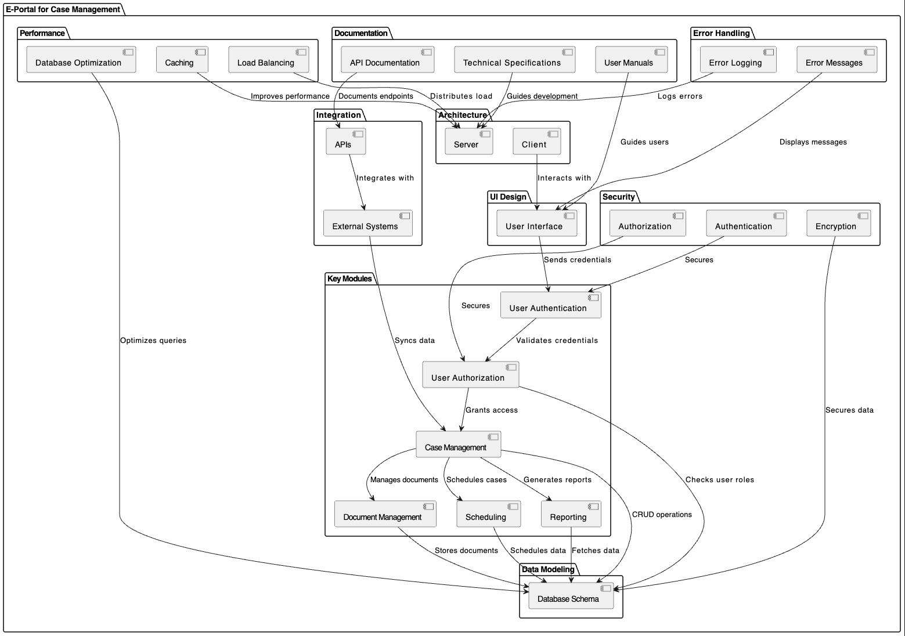

**Fig 3.1 Workflow of the proposed model**

The first step in the software design process is to define the overall architecture of the e-portal. This includes determining the high-level structure, such as the client-server model or the microservices architecture. The choice of architecture depends on factors like scalability, performance, and maintainability requirements.

Next, the key modules and components of the e-portal are identified. These may include user authentication and authorization, case management, document management, scheduling, and reporting modules. Each module is responsible for a specific set of functionalities and interacts with other modules to achieve the overall system goals.

The user interface (UI) design is a critical aspect of the software design phase. The UI should be intuitive, user-friendly, and responsive across different devices. Wireframes and mockups are created to visualize the layout, navigation, and interaction flows of the e-portal. User feedback and usability testing are conducted to refine the UI design iteratively.

Data modeling is another essential aspect of software design. It involves defining the structure and relationships of the data entities used in the e-portal. This includes designing the database schema, specifying data types, and establishing data integrity constraints. The data model should be optimized for efficient storage, retrieval, and manipulation of case-related information.

Integration with external systems and APIs is also considered during the software design phase. The e-portal may need to interact with existing court management systems, legal databases, or third-party services. The design should incorporate appropriate integration mechanisms, such as REST APIs or webhooks, to enable seamless data exchange and synchronization.

Security and privacy considerations are paramount in the design of the e-portal. The system should incorporate robust authentication and authorization mechanisms to ensure that only authorized users can access sensitive case information. Encryption techniques, such as SSL/TLS, should be employed to protect data in transit and at rest. The design should also comply with relevant legal and regulatory requirements, such as data protection laws.

Performance and scalability are key factors in software design. The e-portal should be designed to handle a large volume of cases and users concurrently. Techniques like load balancing, caching, and database optimization are considered to ensure optimal performance under varying loads. The design should also allow for horizontal and vertical scaling to accommodate future growth.

Error handling and logging mechanisms are incorporated into the software design. This includes defining appropriate error messages, implementing error logging, and establishing procedures for troubleshooting and debugging. Proper error handling ensures that the system remains stable and provides meaningful feedback to users in case of exceptions or failures.

Documentation is an integral part of the software design process. This includes creating technical specifications, API documentation, and user manuals. Clear and comprehensive documentation aids in the implementation, testing, and maintenance phases of the project.

The software design phase culminates in the creation of a detailed design document that serves as a blueprint for the development team. The design document outlines the system architecture, module specifications, data models, UI designs, integration points, security measures, and performance considerations.

By following a structured software design approach, the e-portal project can ensure that the system is well-architected, modular, scalable, secure, and user-friendly. The design phase lays the foundation for the successful implementation and deployment of the e-portal, enabling efficient case management and improved access to justice.

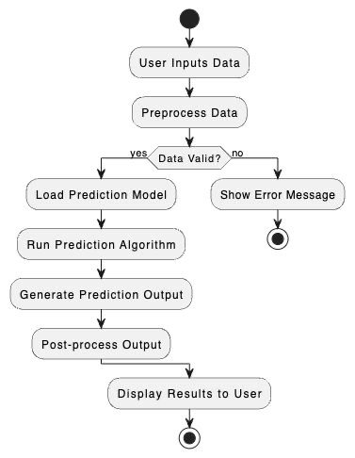

**Fig 3.2 Data Processing for the output**

**Chapter 4**

**Requirements and Methodology**

This chapter focuses on the requirements and methodology for developing the e-portal for case management. It outlines the necessary hardware and software components and describes the approach and techniques used to build the system.

**4.1 Requirements**

The requirements section is divided into two parts: hardware requirements and software requirements. These requirements ensure that the e-portal can be developed, deployed, and used effectively.

**4.1.1 Hardware Requirements**

The hardware requirements specify the physical components needed to run the e-portal. This may include:

* Server infrastructure: Adequate server hardware with sufficient processing power, memory, and storage to handle the expected load and data storage needs.
* ⁠⁠Client devices: Compatible computers, laptops, or mobile devices for users to access the e-portal.
* ⁠Networking equipment: Routers, switches, and firewalls to establish secure and reliable network connectivity.
* ⁠Backup and recovery systems: Hardware for data backup and disaster recovery purposes.

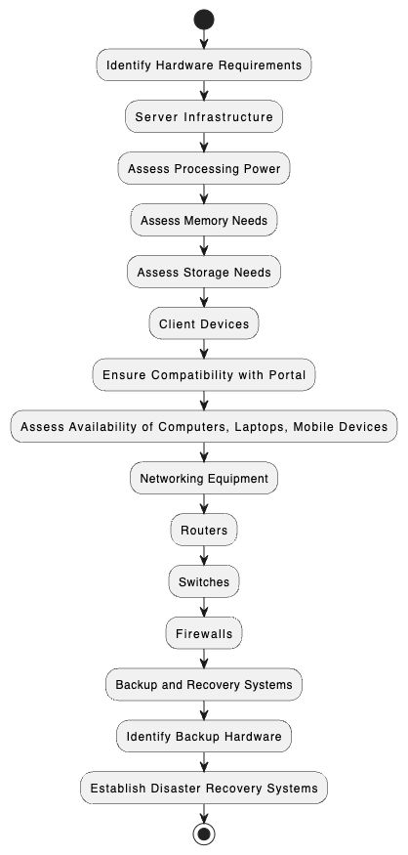

**Fig 4.1 Workflow for the proposed methodology**

**4.1.2 Software Requirements**

The software requirements outline the necessary software components and technologies required to develop and operate the e-portal. This may include:

* Operating systems: Suitable operating systems for servers and client devices.
* ⁠⁠Web server: A web server software like Apache or Nginx to host the e-portal.
* ⁠⁠Database management system: A robust database system like MySQL, PostgreSQL, or MongoDB to store and manage case-related data.
* Programming languages and frameworks: Appropriate programming languages (e.g., Java, Python, JavaScript) and frameworks (e.g., Spring, Django, React) for developing the e-portal.
* Integrated Development Environment (IDE): An IDE for writing, debugging, and testing the code.
* Version control system: A version control system like Git to manage source code and facilitate collaboration among developers.
* Security software: Firewalls, antivirus, and intrusion detection systems to protect the e-portal from security threats.

**4.2 Methodology**

The methodology section describes the approach and techniques used to develop the e-portal. It outlines the process followed to ensure the successful completion of the project.

**4.2.1 (Agile Development)**

Agile development methodologies, such as Scrum or Kanban, can be used to develop the e-portal. Agile approaches prioritize iterative development, frequent deliverables, and close collaboration between the development team and stakeholders. This allows for flexibility, adaptability, and continuous improvement throughout the project.

**4.2.2 (User-Centered Design)**

User-centered design principles can be employed to ensure that the e-portal meets the needs and expectations of its users. This involves conducting user research, creating user personas, and developing intuitive user interfaces. Regular user testing and feedback loops help refine the design and improve the overall user experience.

**4.2.3 (Continuous Integration and Deployment)**

Continuous Integration and Continuous Deployment (CI/CD) practices can be implemented to streamline the development and deployment process. CI involves regularly merging code changes into a central repository and running automated tests to ensure code quality. CD automates the deployment process, enabling frequent releases and reducing manual effort.

The methodology section can further include details on project management tools, communication protocols, testing strategies, and deployment processes specific to the e-portal project.

By clearly defining the requirements and methodology, the project team can ensure a structured and efficient approach to developing the e-portal. The hardware and software requirements provide the necessary foundation, while the methodology outlines the processes and techniques used to deliver a high-quality and user-centric solution.

**4.2.4 Pseudocode for video conferencing**

**Variables:**

1. **participantsList: A list that keeps track of everyone in the video call.**
2. **videoMeters: A dictionary that stores the video settings for each participant.**
3. **maxVideoBitrate: The highest quality allowed for video (measured in kilobits per second).**
4. **totalVideoBitrate: The total amount of video quality being used by all participants.**

**Functions:**

1. **startVideoConference:**
   * **Sets up the internet connection.**
   * **Displays the user interface.**
   * **Starts the video streams.**
2. **addParticipant:**
   * **Adds a new person to the video call.**
   * **Initializes their video settings to 0.**
3. **removeParticipant:**
   * **Removes a person from the video call.**
   * **Deletes their video settings.**
   * **Updates the video quality settings for everyone else in the call.**
4. **recalculateVideoBitrates:**
   * **Resets the total video quality being used to 0.**
   * **For each person in the call:**
     + **Shares the maximum video quality equally among all participants.**
     + **Adds each participant's video quality to the total video quality being used.**
   * **Adjusts the video quality settings for everyone in the call.**
5. **adjustVideoStreams:**
   * **For each person in the call:**
     + **Sets their video quality based on the updated settings.**
6. **setVideoBitrate:**
   * **Changes the video quality for a specific person.**
7. **handleNetworkConditions:**
   * **Monitors the internet connection.**
   * **If the internet connection changes, it updates the video quality settings for everyone.**

**Main Program:**

1. **startVideoConference:**
   * **Starts the video conference by setting up the connection, showing the interface, and starting the video streams.**
2. **while True:**
   * **Continuously:**
     + **Handles user actions.**
     + **Monitors and handles changes in the internet connection.**
     + **Performs other necessary tasks for the application.**

**4.2.5 Pseudocode for web application**

#### **BEGIN:**

1.⁠ ⁠Import required modules and dependencies

* Express.js for creating the web application
* EJS for rendering views
* Passport for authentication
* Mongoose for connecting to MongoDB database
* Other necessary modules (flash, session, etc.)

2.⁠ ⁠Configure the application

* Set up the database connection using Mongoose
* Configure middleware for serving static files, parsing request bodies, and handling sessions
* Initialize Passport for authentication
* Set up flash message handling using connect-flash

 3.⁠ ⁠Define routes

* Set up routes for different parts of the application using ⁠ app.use() ⁠
* Import route handlers from separate files in the ⁠ routes ⁠ directory
* Index route ('/') for the main application entry point
* Client route ('/client') for client-specific functionality
* Lawyer route ('/lawyer') for lawyer-specific functionality
* Chat route ('/chat') for chat-related functionality

 4.⁠ ⁠Start the server

* Set the port number for the server to listen on
* Start the server and log a message when it starts running

 5.⁠ ⁠Route handling

* When a request comes in, Express.js matches the requested URL to the defined routes
* The corresponding route handler function is executed
* The route handler can perform various actions based on the request:
* Retrieve data from the database using Mongoose
* Render views using EJS templates
* Handle form submissions and process user input
* Authenticate users using Passport
* Set flash messages for success or error notifications
* Redirect to different pages based on the application logic

 6.⁠ ⁠Database interaction

* Mongoose is used to interact with the MongoDB database
* Define database schemas and models using Mongoose
* Perform CRUD operations (Create, Read, Update, Delete) on the database
* Retrieve data from the database to be used in the application

 7.⁠ ⁠Authentication

* Passport is used for user authentication
* Configure Passport strategies (e.g., local strategy) for authentication
* Handle user login, registration, and logout functionality
* Protect certain routes or functionality based on user authentication status

 8.⁠ ⁠Error handling and logging

* Implement error handling middleware to catch and handle errors gracefully
* Log errors or important events for debugging and monitoring purposes

 9.⁠ ⁠View rendering

* Use EJS templates to render dynamic views
* Pass data from the server to the views for rendering
* Utilize layouts and partials for reusable components

10.⁠ ⁠Client-server communication

* Handle client-side requests and respond with appropriate data or views
* Process form submissions and update the database accordingly
* Utilize AJAX or WebSocket for real-time communication between the client and server.

**END**

It demonstrates the flow of the application, from setting up the server and database connection to handling routes, authentication, database interactions, and rendering views.

**Chapter 5**

**Coding/Code Templates**

**5.1 Authentication Middleware**

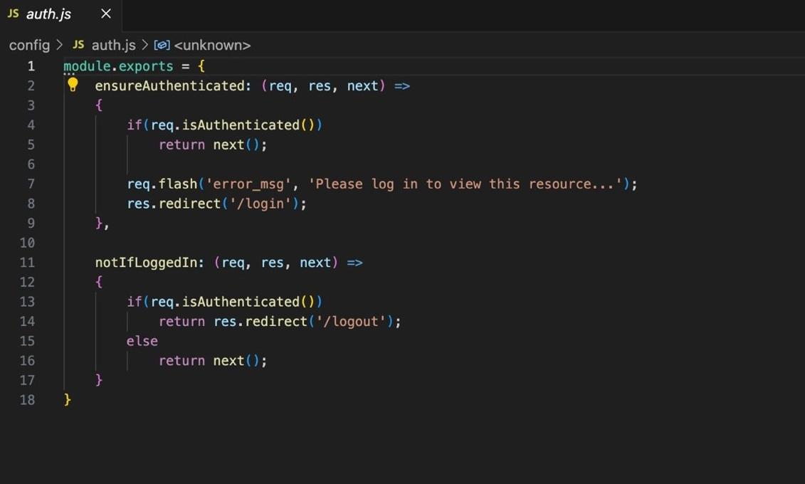

**Fig 5.1 Code Snippet for Authentication Middleware**

**1.⁠ ⁠⁠ EnsureAuthenticated ⁠:**

* This middleware checks if the user is authenticated.
* If the user is authenticated (⁠ req.isAuthenticated() ⁠ returns ⁠ true ⁠), it allows the request to proceed to the next middleware or route handler by calling ⁠ next() ⁠.
* If the user is not authenticated, it sets a flash message (⁠ 'Please log in to view this resource...' ⁠) to be displayed to the user and redirects them to the login page (⁠ '/login' ⁠).

**2.⁠ ⁠⁠ NotIfLoggedIn ⁠:**

* This middleware is used to restrict access to certain routes if the user is already logged in.
* If the user is authenticated (⁠ req.isAuthenticated() ⁠ returns ⁠ true ⁠), it redirects them to the logout page (⁠ '/logout' ⁠).
* If the user is not authenticated, it allows the request to proceed to the next middleware or route handler by calling ⁠ next() ⁠.
* These middleware functions are typically used in the route definitions to control access to specific routes based on the user's authentication status.
* ⁠The ⁠ ensure Authenticated ⁠ middleware ensures that only authenticated users can access protected routes. It can be placed before the route handlers that require authentication.
* ⁠The ⁠ notIfLoggedIn ⁠ middleware prevents authenticated users from accessing routes that are meant for unauthenticated users, such as the login or registration pages. It can be placed before the route handlers for those pages.

**5.2 User Model**

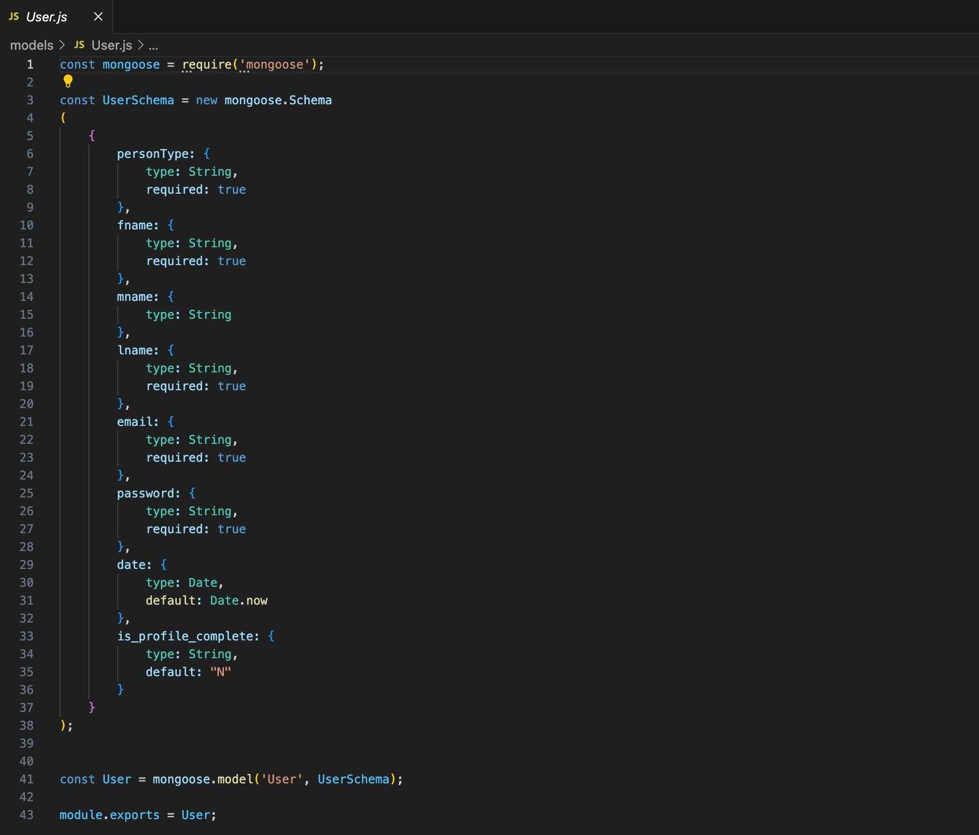

**Fig 5.2 Code Snippet for User Model**

1. The code imports the Mongoose library using ⁠ require('mongoose') ⁠.
2. ⁠It creates a new Mongoose schema called ⁠ UserSchema ⁠ using ⁠ new mongoose.Schema ⁠.
3. The ⁠ UserSchema ⁠ defines the structure and properties of a User document in the database. It includes the following fields:
   1. personType ⁠: Represents the type of person and is of type String. It is a required field.
   2. fname ⁠: Represents the first name of the user and is of type String. It is a required field.
   3. mname ⁠: Represents the middle name of the user and is of type String.
   4. lname ⁠: Represents the last name of the user and is of type String. It is a required field.
   5. email ⁠: Represents the email address of the user and is of type String. It is a required field.
   6. password ⁠: Represents the password of the user and is of type String. It is a required field.
   7. date ⁠: Represents the date associated with the user and is of type Date. It has a default value of the current date (⁠ Date.now ⁠).
   8. is_profile_complete ⁠: Represents whether the user's profile is complete and is of type String. It has a default value of "N".
4. The ⁠ UserSchema ⁠ is then used to create a Mongoose model called ⁠ User ⁠ using ⁠ mongoose.model('User', UserSchema) ⁠. This model provides an interface to interact with the User documents in the database.
5. ⁠Finally, the ⁠ User ⁠ model is exported using ⁠ module.exports = User ⁠, making it available for other parts of the application to use.

This code sets up a blueprint (schema) for a User document in the database. It defines the fields that a User document should have, such as ⁠ personType ⁠, ⁠ fname ⁠, ⁠ email ⁠, ⁠ password ⁠, etc. Some fields are marked as required, meaning they must be provided when creating a new User document.

The code then creates a User model based on this schema, which allows the application to perform database operations (e.g., create, read, update, delete) on User documents.

By exporting the User model, other parts of the application can import and use it to interact with the User documents in the database.

2

**5.3 Case Details Model**

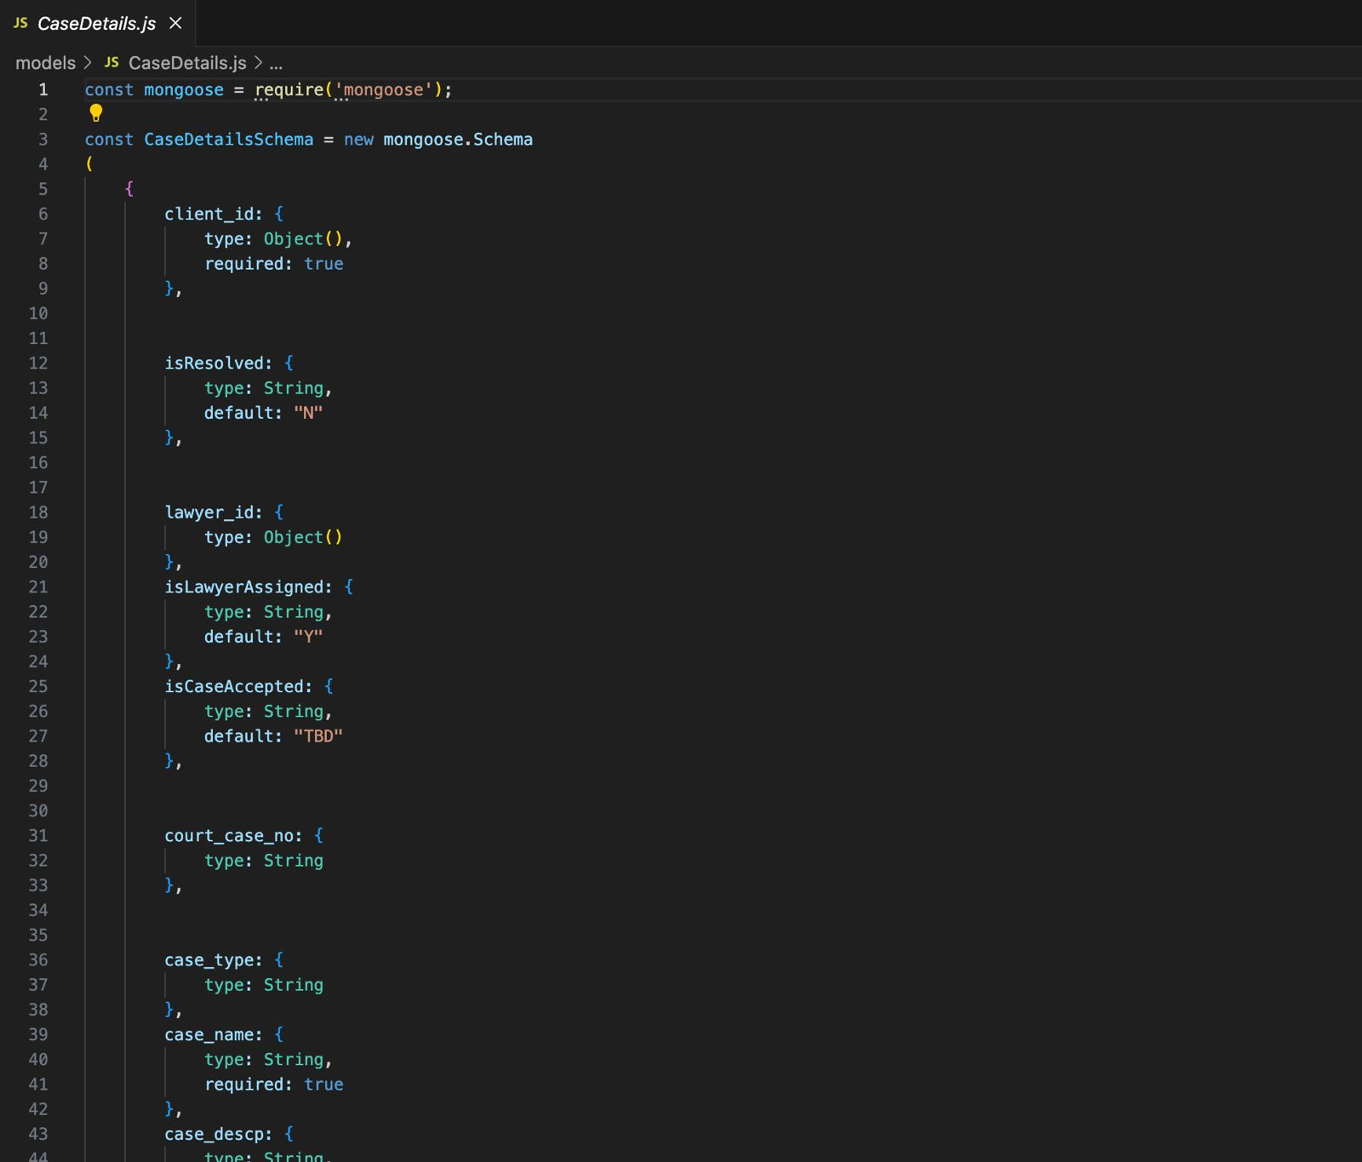

**Fig 5.3 Code Snippet for Case Details Model**

The provided code defines a Mongoose schema called ⁠ CaseDetailsSchema ⁠ for storing case details in a web application.

1. The code imports the Mongoose library using ⁠ require('mongoose') ⁠.
2. It creates a new Mongoose schema called ⁠ CaseDetailsSchema ⁠ using ⁠ new mongoose.Schema ⁠.
3. ⁠The ⁠ CaseDetailsSchema ⁠ defines the structure and properties of a case details document in the database. It includes the following fields:
   1. client_id ⁠: Represents the ID of the client associated with the case. It is of type ⁠ Object() ⁠ and is a required field.
   2. isResolved ⁠: Represents whether the case is resolved or not. It is of type String and has a default value of "N".
   3. lawyer_id ⁠: Represents the ID of the lawyer assigned to the case. It is of type ⁠ Object() ⁠.
   4. isLawyerAssigned ⁠: Represents whether a lawyer is assigned to the case or not. It is of type String and has a default value of "N".
   5. isCaseAccepted ⁠: Represents whether the case is accepted or not. It is of type String and has a default value of "TBD".
   6. court_case_no ⁠: Represents the court case number associated with the case. It is of type String.
   7. case_type ⁠: Represents the type of the case. It is of type String.
   8. case_name ⁠: Represents the name of the case. It is of type String and is a required field.
   9. case_descr ⁠: Represents the description of the case. It is of type String.

4.⁠ ⁠The ⁠ CaseDetailsSchema ⁠ is then used to create a Mongoose model called ⁠ CaseDetails ⁠ using ⁠ mongoose.model('CaseDetails', CaseDetailsSchema) ⁠. This model provides an interface to interact with the case details documents in the database.

5.⁠ ⁠Finally, the ⁠ CaseDetails ⁠ model is exported using ⁠ module.exports = CaseDetails ⁠, making it available for other parts of the application to use.

In simple terms, this code sets up a blueprint (schema) for a case details document in the database. It defines the fields that a case details document should have, such as ⁠ client_id ⁠, ⁠ isResolved ⁠, ⁠ lawyer_id ⁠, ⁠ case_name ⁠, etc. Some fields are marked as required, meaning they must be provided when creating a new case details document.

The code then creates a ⁠ CaseDetails ⁠ model based on this schema, which allows the application to perform database operations (e.g., create, read, update, delete) on case details documents.

By exporting the ⁠ CaseDetails ⁠ model, other parts of the application can import and use it to interact with the case details documents in the database.

**5.4 Lawyer Details Model**

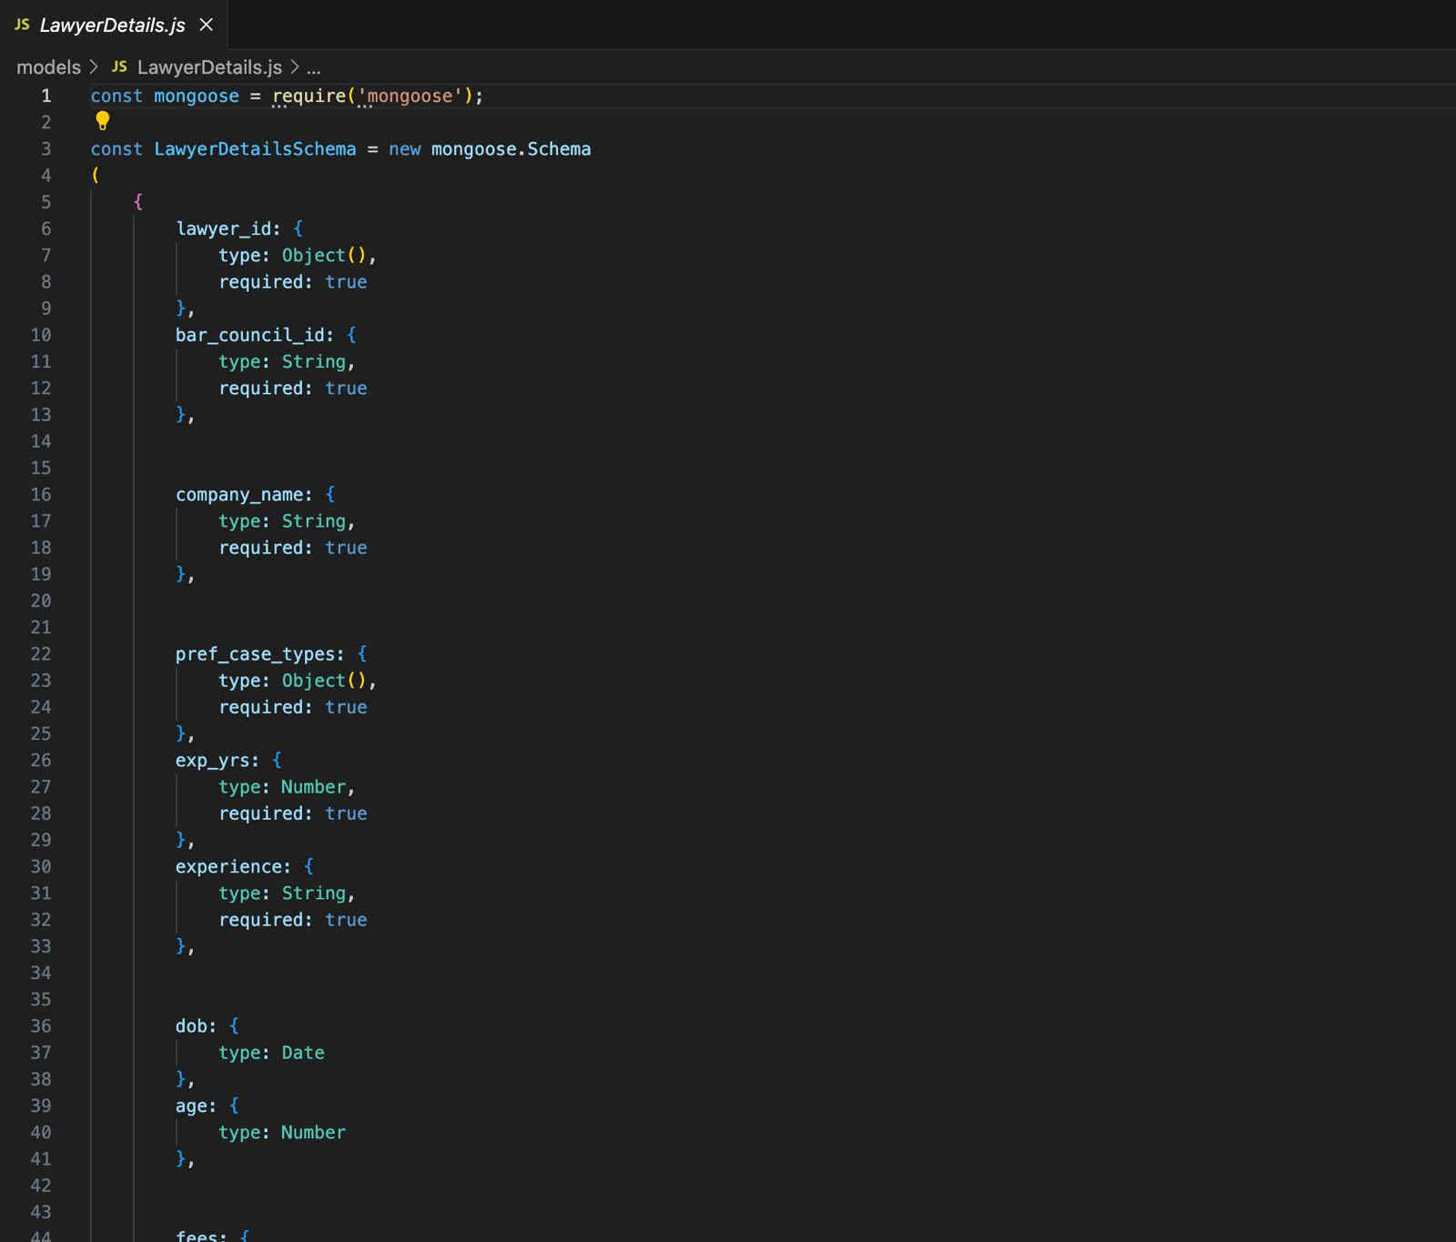

**Fig 5.4 Code Snippet for Lawyer Details Model**

The provided code defines a Mongoose schema called ⁠ LawyerDetailsSchema ⁠ for storing lawyer details in a web application.

1. ⁠The code imports the Mongoose library using ⁠ require('mongoose') ⁠.
2. ⁠It creates a new Mongoose schema called ⁠ LawyerDetailsSchema ⁠ using ⁠ new mongoose.Schema ⁠.
3. The ⁠ LawyerDetailsSchema ⁠ defines the structure and properties of a lawyer details document in the database. It includes the following fields:
   1. lawyer_id ⁠: Represents the ID of the lawyer. It is of type ⁠ Object() ⁠ and is a required field.
   2. bar_council_id ⁠: Represents the bar council ID of the lawyer. It is of type String and is a required field.
   3. company_name ⁠: Represents the name of the company the lawyer works for. It is of type String and is a required field.
   4. pref_case_types ⁠: Represents the preferred case types of the lawyer. It is of type ⁠ Object() ⁠ and is a required field.
   5. exp_yrs ⁠: Represents the years of experience of the lawyer. It is of type Number and is a required field.
   6. experience ⁠: Represents the experience details of the lawyer. It is of type String and is a required field.
   7. dob ⁠: Represents the date of birth of the lawyer. It is of type Date.
   8. age ⁠: Represents the age of the lawyer. It is of type Number.
   9. fees ⁠: Represents the fees charged by the lawyer. It is of type Object.
4. The ⁠ LawyerDetailsSchema ⁠ is then used to create a Mongoose model called ⁠ LawyerDetails ⁠ using ⁠ mongoose.model('LawyerDetails', LawyerDetailsSchema) ⁠. This model provides an interface to interact with the lawyer details documents in the database.
5. Finally, the ⁠ LawyerDetails ⁠ model is exported using ⁠ module.exports = LawyerDetails ⁠, making it available for other parts of the application to use.

In simple terms, this code sets up a blueprint (schema) for a lawyer details document in the database. It defines the fields that a lawyer details document should have, such as ⁠ lawyer_id ⁠, ⁠ bar_council_id ⁠, ⁠ company_name ⁠, ⁠ pref_case_types ⁠, ⁠ exp_yrs ⁠, etc. Some fields are marked as required, meaning they must be provided when creating a new lawyer details document.

The code then creates a ⁠ LawyerDetails ⁠ model based on this schema, which allows the application to perform database operations (e.g., create, read, update, delete) on lawyer details documents.

By exporting the ⁠ LawyerDetails ⁠ model, other parts of the application can import and use it to interact with the lawyer details documents in the database.

**5.5 Add New Court Case Form**

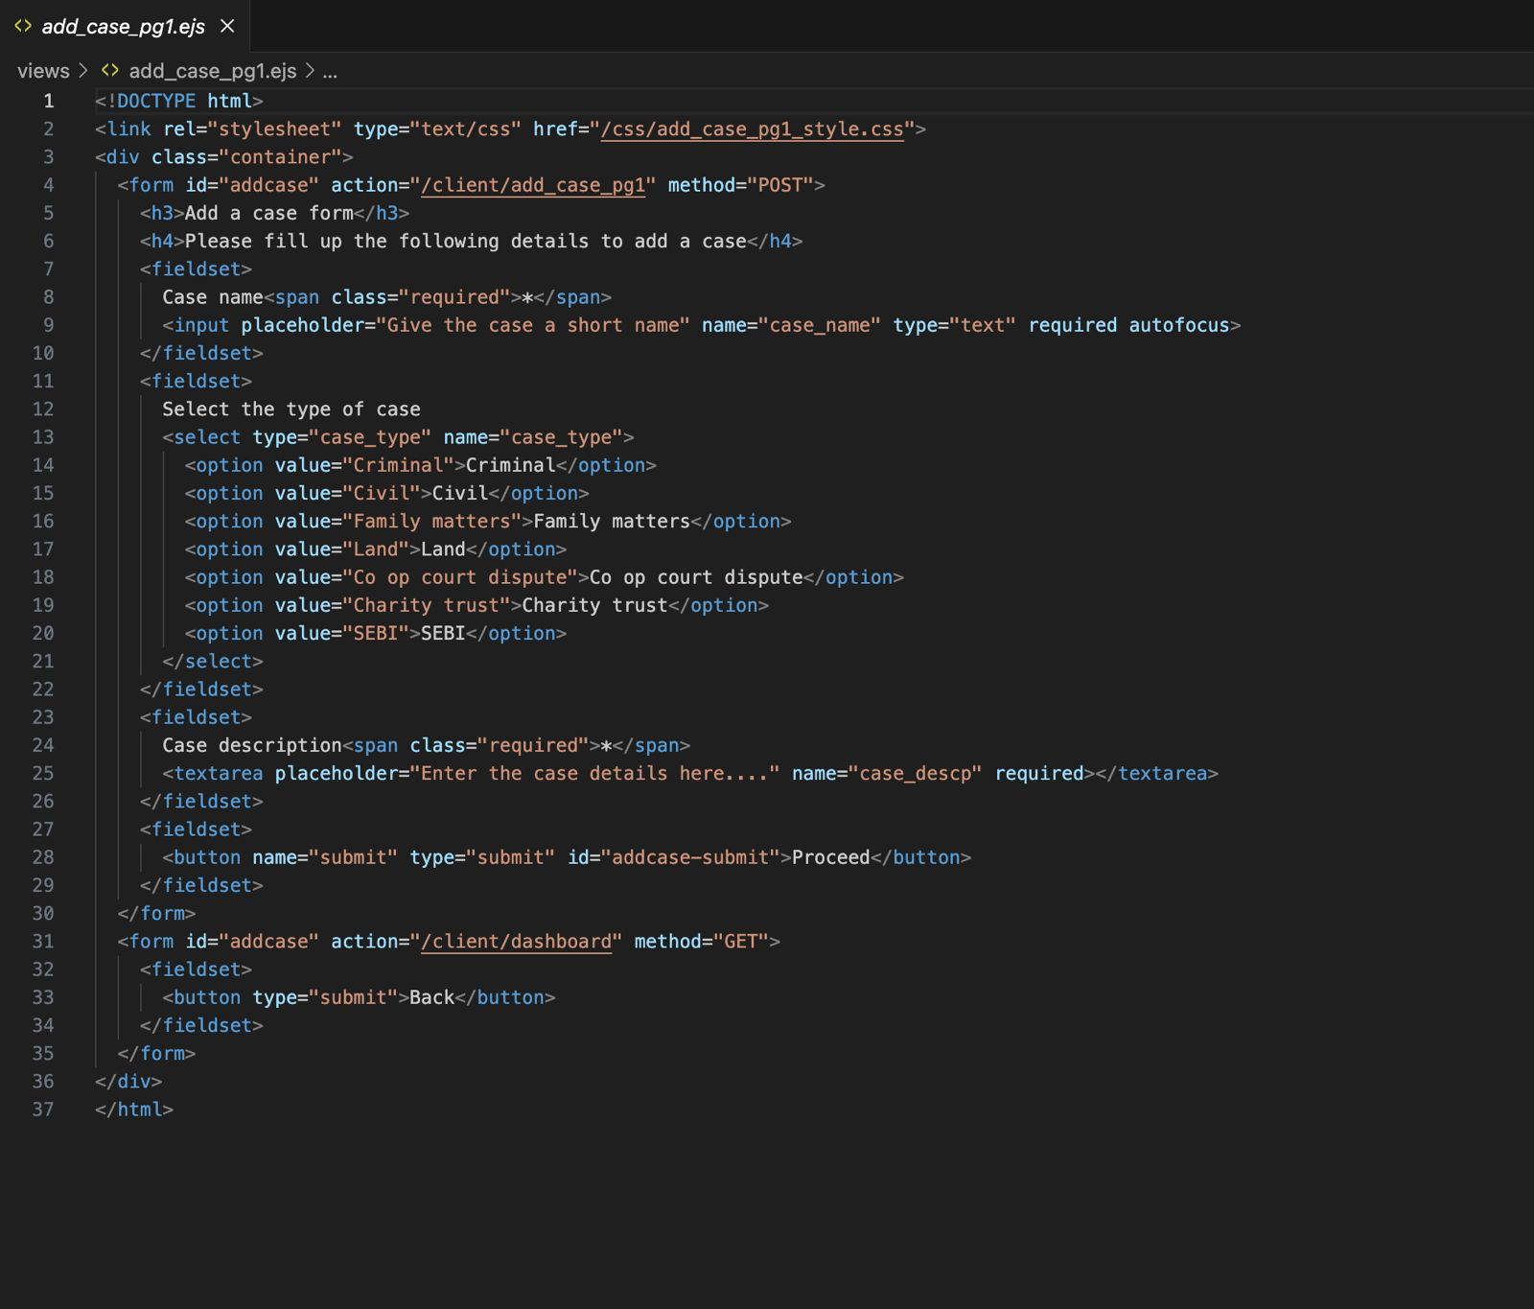

**Fig 5.5 Code Snippet for Add New Court Case Form**

This code represents an HTML form for adding a new court case to a system. Here's a simplified explanation:

1. The code includes a link to a CSS file for styling the form.
2. The form has an ID "addcase" and submits data to the "/client/add_case_pg1" URL using the POST method.
3. The form asks the user to fill in the following details to add a case:
   1. Case name (a short name for the case)
   2. Case type (selected from options like Civil, Family matters, Land, Co op court dispute, Charity trust, SEBI)
   3. Case description (details about the case entered in a text area)
4. ⁠After filling in the case details, the user can click the "Proceed" button to submit the form.
5. The form also includes a "Back" button, which likely takes the user back to the dashboard or previous page.

Overall, this code provides a user-friendly interface for clients to add new court cases to the system by entering essential details such as the case name, type, and description.

**5.6 User Authentication with Passport.js**

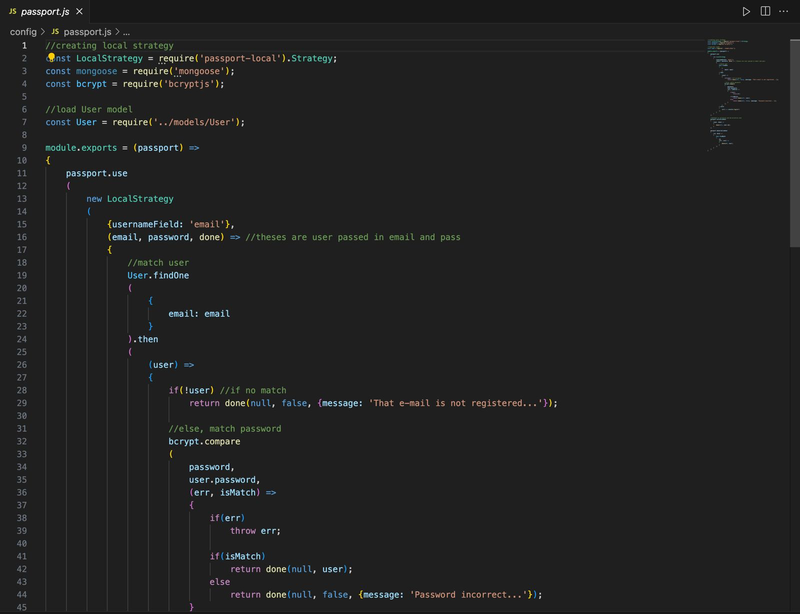

**Fig 5.6 Code Snippet for User Authentication for Passport.js**

This code implements a user authentication strategy using Passport.js library.

1. The code creates a local strategy using the 'passport-local' module.
2. It defines a mongoose model named 'User' and requires the bcrypt library for password hashing.
3. The strategy uses the 'usernameField' option set to 'email', meaning the user's email will be used as the username for authentication.
4. The strategy receives the user's email and password.
5. It then tries to find a user in the database with the provided email.
   1. If no user is found, it returns an error message saying "That e-mail is not registered".
   2. If a user is found, it compares the provided password with the hashed password stored in the database using bcrypt.
   3. If the passwords don't match, it returns an error message saying "Password incorrect".
   4. If the passwords match, it returns the authenticated user object.
6. ⁠The code exports the configured Passport instance so that it can be used in other parts of the application.

In simple terms, this code sets up a way to verify user logins by checking their email and password against the information stored in the database. If the email and password are correct, the user is authenticated and allowed to access protected parts of the application.

**5.7 Meeting Room Validation API**

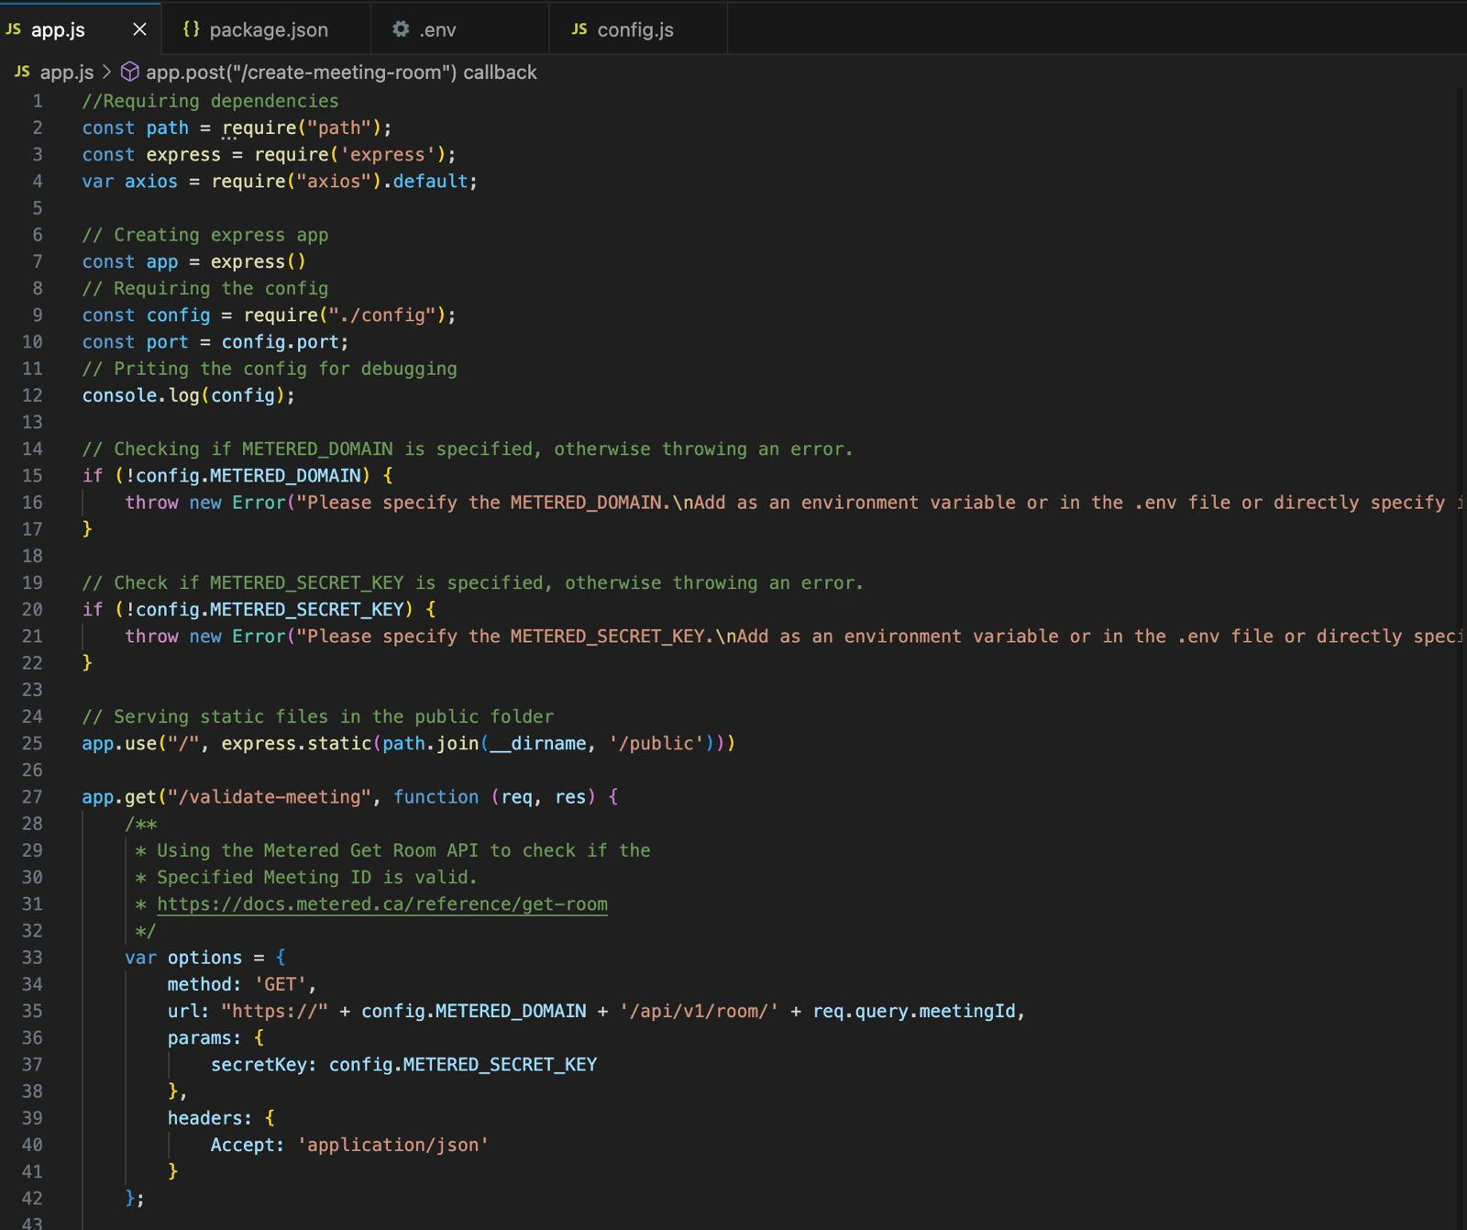

**Fig 5.7 Code Snippet for meeting room validation**

This code implements an API for meeting room.

1.⁠ ⁠Require dependencies: path and express

 2.⁠ ⁠Set up express app

 3.⁠ ⁠Require axios library and set default

 4.⁠ ⁠Require config file

 5.⁠ ⁠Set port based on config or default

 6.⁠ ⁠Print config for debugging

 7.⁠ ⁠Check if METERED_DOMAIN environment variable is specified, otherwise throw error

 8.⁠ ⁠Check if METERED_SECRET_KEY environment variable is specified, otherwise throw error

 9.⁠ ⁠Serve static files from the public folder

10.⁠ ⁠Define a GET endpoint '/validate-meeting' that:

- Uses the Metered Get Room API to check if the specified Meeting ID is valid

- Constructs the API URL using the METERED_DOMAIN and meeting ID from the request query

- Sets the secretKey in the params from the METERED_SECRET_KEY in config

- Sets the Accept header to 'application/json'

- Sends the response back to the client

11.⁠ ⁠Start the express app and listen on the specified port

**5.8 Meeting Join/Create Functions**

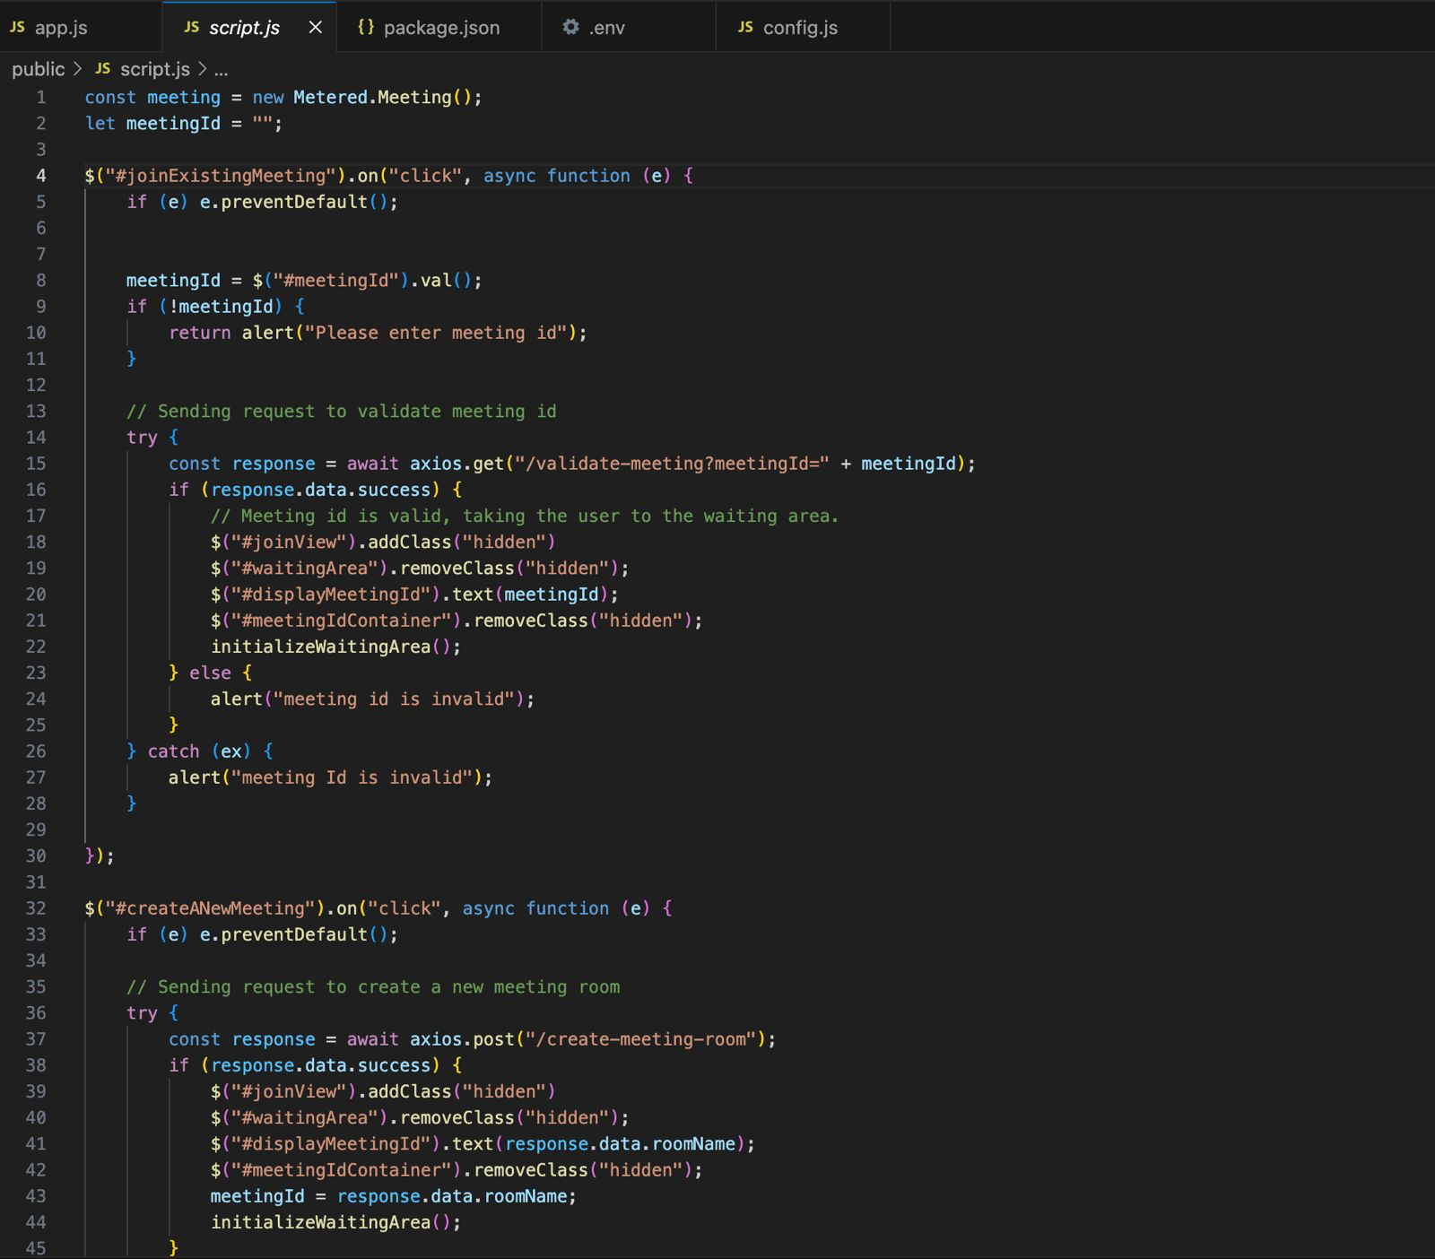

**Fig 5.8 Code Snippet for meeting creation**

This code implements create/join functions for the video conferencing process.

1.⁠ ⁠Initialize a new Metered.Meeting()

2.⁠ ⁠Initialize meetingId variable as empty string

3.⁠ ⁠Add click event listener to '#joinExistingMeeting' element

- Prevent default behavior

- Get meetingId value from input

- If meetingId is empty, prompt user to enter it

- Send request to validate meeting id

- Make GET request to "/validate-meeting?meetingId=" endpoint with the meetingId

- If response is successful (meeting id is valid):

- Remove "hidden" class from "#waitingArea"

- Set text of "#displayMeetingId" to the meetingId

- Remove "hidden" class from "#meetingIdContainer"

- Initialize waitingArea

- Else (meeting id is invalid):

- Alert user that the meeting id is invalid

- Catch any errors and alert that the meeting id is invalid

4.⁠ ⁠Add click event listener to '#createANewMeeting' element

- Prevent default behavior

- Send request to create a new meeting room

- Make POST request to "/create-meeting-room" endpoint

- If response is successful:

- Add "hidden" class to "#joinView"

- Remove "hidden" class from "#waitingArea"

- Set text of "#displayMeetingId" to the response.data.roomName

- Remove "hidden" class from "#meetingIdContainer"

- Set meetingId to response.data.roomName

- Initialize waitingArea

## **Chapter 6**

# **Testing**

**6.1 Black Box Testing:**

Black Box Testing is a software testing method that focuses on the inputs and outputs of the system, without considering the internal structure. Testers interact with the e-court system as external users. This approach is used to evaluate the functionality of the system.

**6.1.1 Test Case 1: Verify Login Functionality**

* Preconditions: A user has a valid account in the e-court system.
* Steps:

1. Open the e-court web application.
2. Enter the user's registered email address and password.
3. Click on the "Login" button.

* Expected Result:

1. The user should be successfully logged in and redirected to their dashboard.
2. The user's name should be displayed in the top right corner, indicating a successful login.

**6.1.2 Test Case 2: Verify Case Filing Functionality**

* Preconditions: The user is logged in and has access to the case filing feature.
* Steps:

1. Navigate to the case filing section.
2. Fill in the required details for filing a new case (e.g., case type, parties involved, case description).
3. Attach necessary documents (if applicable).
4. Submit the case filing form.

* Expected Results:

1. The system should display a confirmation message indicating successful case filing.
2. The filed case should appear in the user's case list or dashboard.
3. The system should send a notification to the relevant parties about the new case filing.

**6.2 White Box Testing:**

White Box Testing is a software testing approach that considers the internal structure and logic of the system. Testers have knowledge of how the e-court system works internally and use this understanding to identify any errors. White Box Testing is typically used to verify the accuracy and efficiency of the system's code.

**6.2.1 Test Case 1: Verify User Authentication**

* Preconditions: The user authentication module is implemented.
* Steps:

1. Create test cases for various user authentication scenarios (e.g., valid login, invalid login, forgot password).
2. Verify that the user's credentials are securely stored and hashed in the database.
3. Verify that the authentication process correctly validates user credentials.
4. Verify that the system generates and manages session tokens securely.

* Expected Results:

1. The user authentication module should securely store and hash user credentials.
2. The authentication process should correctly validate user credentials and grant access only to authorized users.
3. The system should generate and manage session tokens securely to prevent unauthorized access.

**6.2.2 Test Case 2: Test Case Assignment Algorithm**

* Preconditions: The case assignment algorithm is implemented.
* Steps:

1. Create test cases with different case types and criteria.
2. Call the case assignment function with the test case data.
3. Verify that the function correctly assigns cases to the appropriate judges based on the defined criteria.
4. Verify that the function handles edge cases and exceptional scenarios gracefully.

* Expected Results:

1. The case assignment function should correctly assign cases to the appropriate judges based on the defined criteria.
2. The function should handle edge cases and exceptional scenarios without errors or inconsistencies.
3. The assigned cases should be accurately reflected in the judges' case lists or dashboards.

By conducting both Black Box and White Box Testing, you can ensure that your e-court system functions as expected from both user and system perspectives, providing a reliable and efficient platform for case management and legal proceedings.

**Chapter 7**

**Results and Discussion**

**7.1 User Registration and Login**

The e-court system provides a seamless and user-friendly interface for new users to register and create their accounts. Users can enter their personal details, such as their name, email address, mobile number, and set a secure password. The registration process is designed to be straightforward and efficient, ensuring that users can quickly get started with the system.

After successful registration, users can log in to the system using their registered email address and the password they set during the registration process. The login process incorporates robust security measures, including password hashing and encryption, to protect user data and ensure the system's integrity.

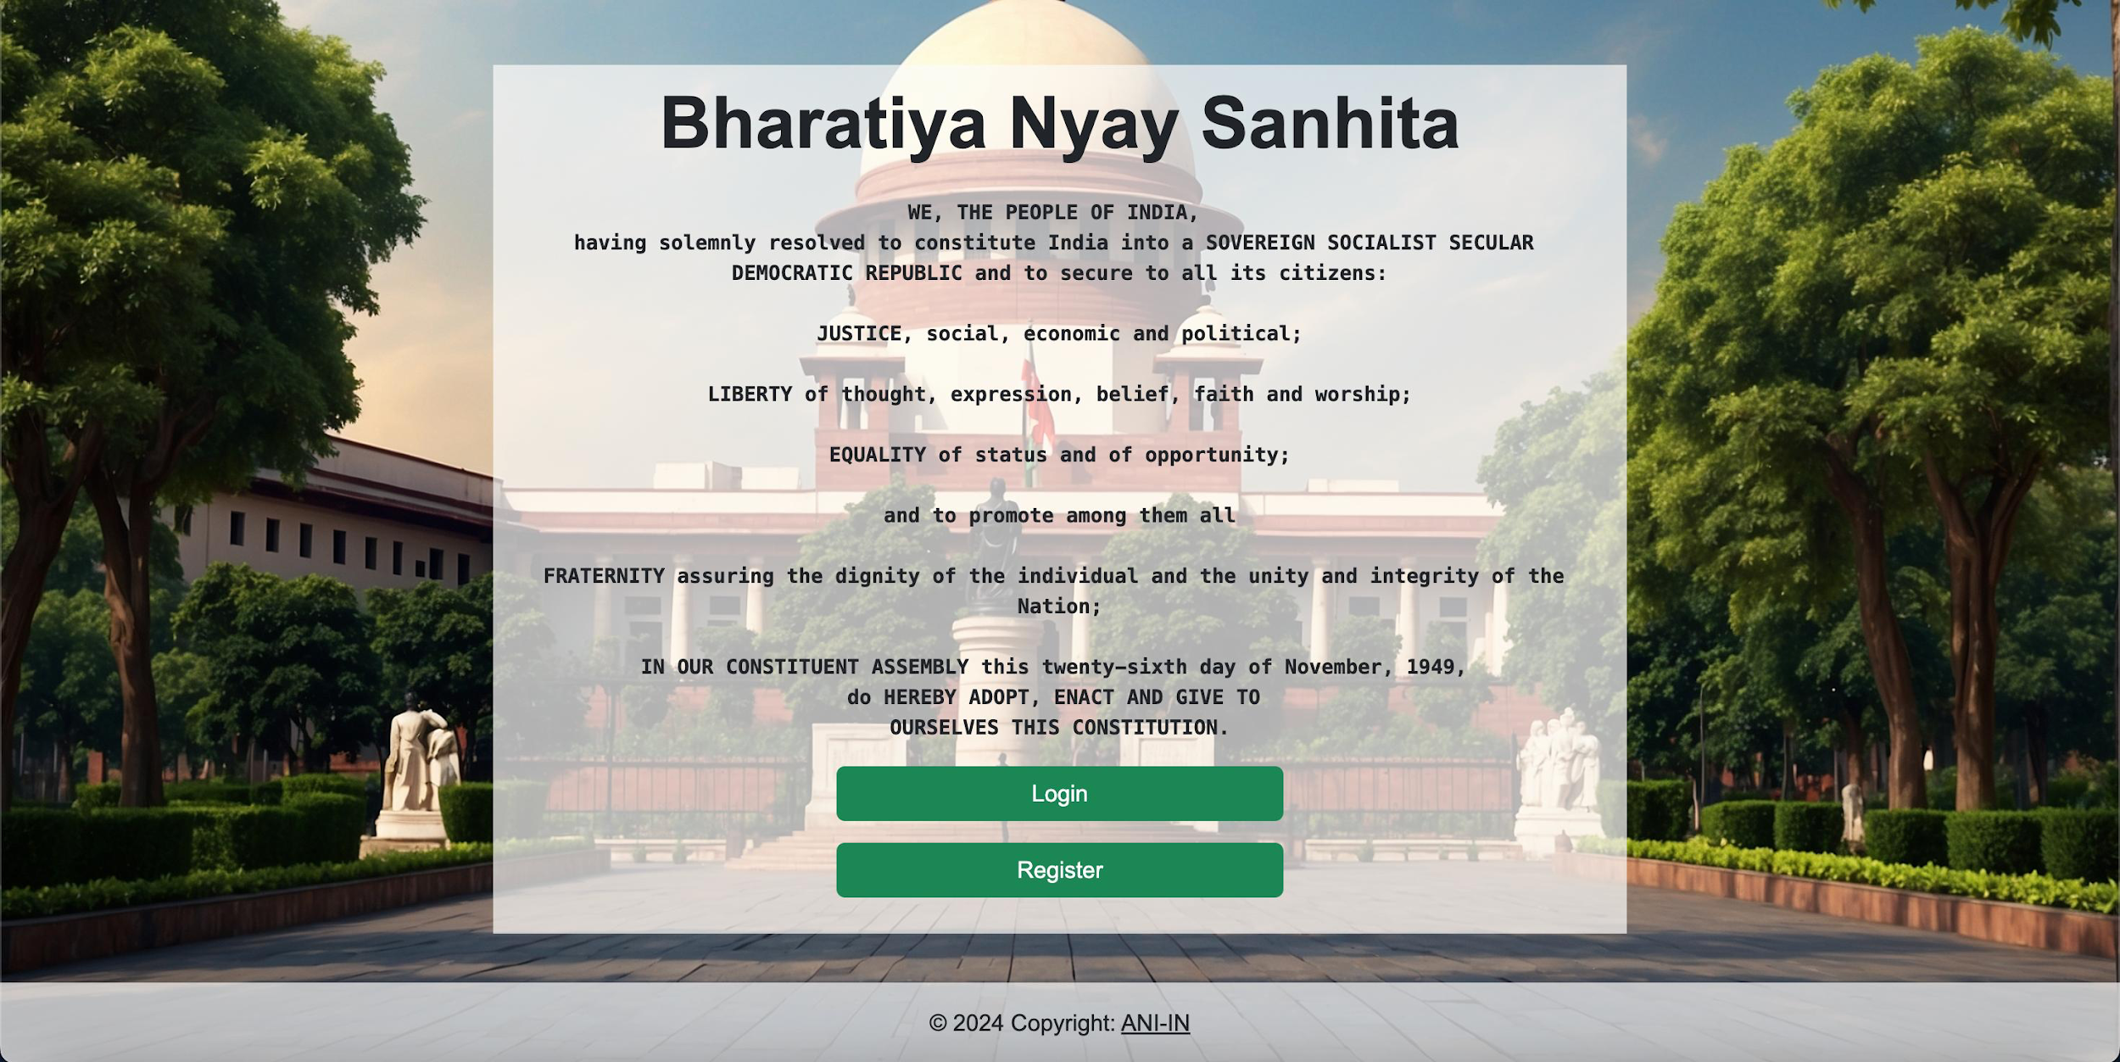

**Fig 7.1 Home Page**

**7.2 Dashboard for Different User Roles**

One of the key features of the e-court system is its ability to cater to different user roles, each with specific needs and responsibilities. The system provides separate dashboards tailored to the requirements of lawyers, clients, court staff, and judges.

The lawyer dashboard is designed to facilitate case management and legal proceedings. It includes features such as case filing, document management, and communication tools to collaborate with clients and other legal professionals. Lawyers can easily access and track the progress of their ongoing cases, ensuring they stay up to date with the latest developments.

The client dashboard offers a transparent and accessible platform for individuals involved in legal cases. Clients can file new cases, upload relevant documents, and communicate with their legal representatives. Additionally, they can track the progress of their cases, receive real-time updates, and stay informed throughout the legal process.

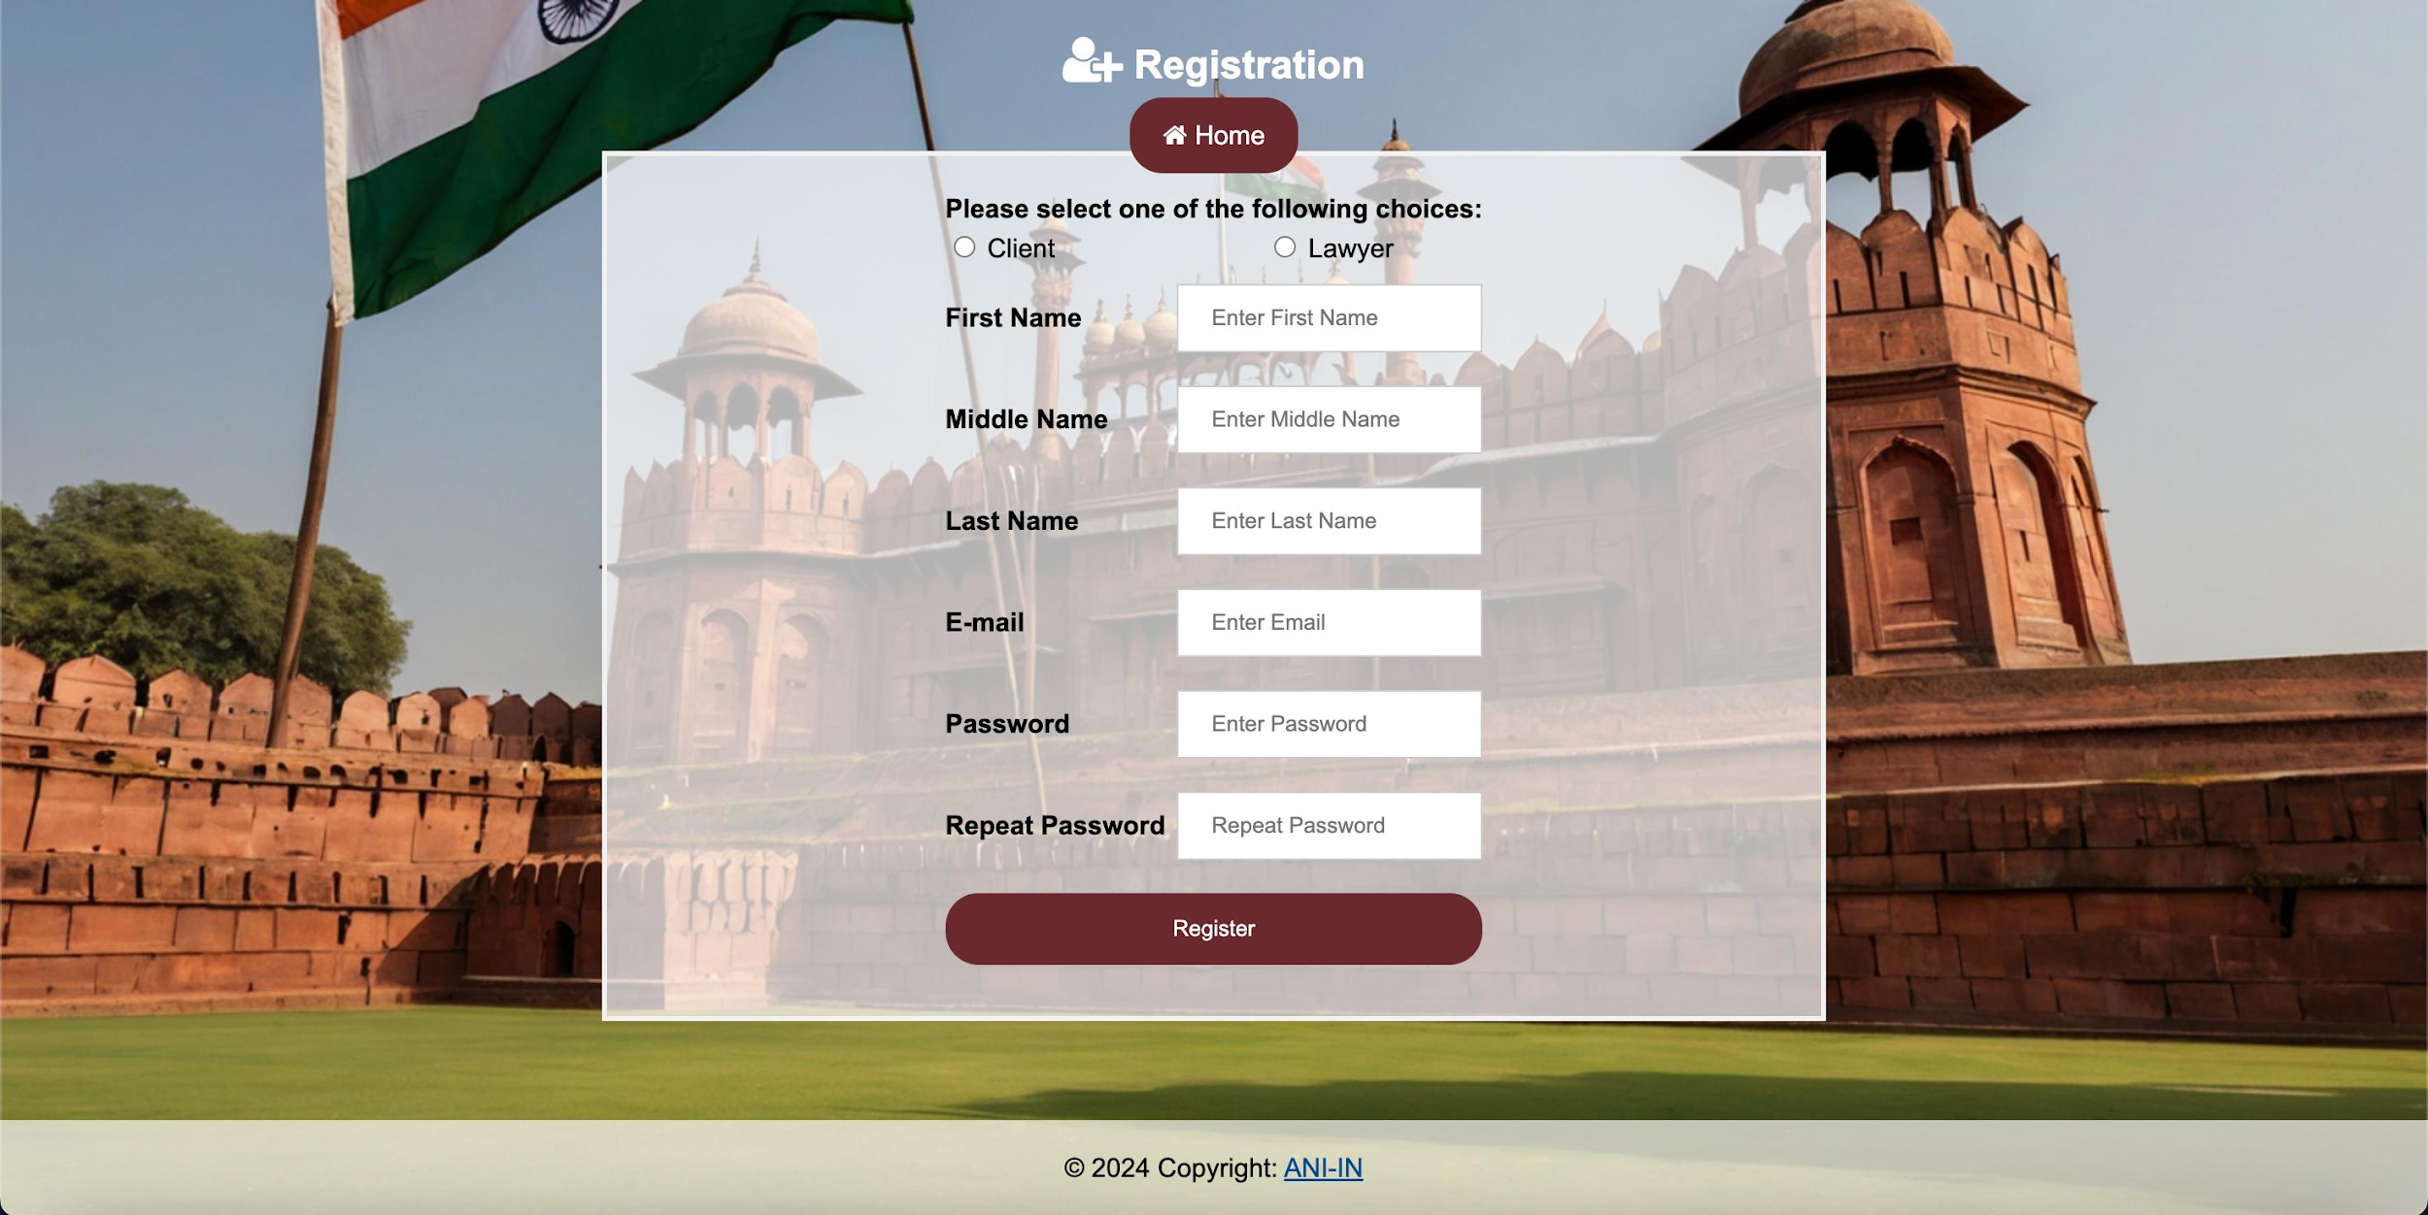

**Fig 7.2 Registration Page for Different User Roles**

**7.3 Case Filing and Tracking**

One of the core functionalities of the e-court system is its ability to facilitate efficient case filing and tracking. Lawyers and clients can easily file new cases by providing relevant case details and uploading necessary documents. The system offers a streamlined process, reducing the need for physical paperwork and minimizing the chances of errors or delays.

Once a case is filed, both lawyers and clients can track its progress through their respective dashboards. Real-time updates and notifications related to the case are displayed, ensuring that all parties involved remain informed about important developments, such as scheduled hearings, document submissions, or court rulings.

The case tracking feature not only enhances transparency but also fosters better communication and collaboration between all stakeholders. Lawyers can provide timely updates to their clients, and clients can stay informed about the progress of their cases without the need for frequent follow-ups or inquiries.

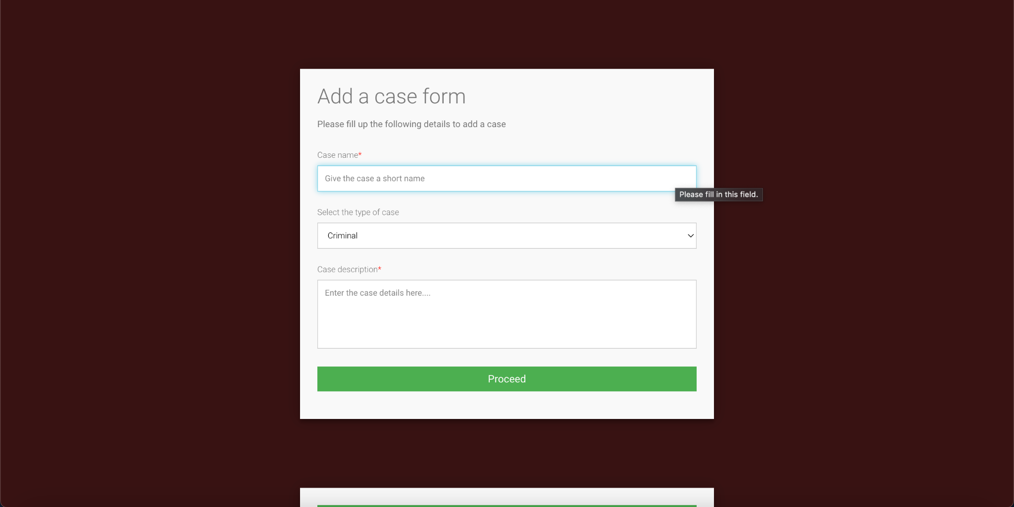

**Fig 7.3 Case Filing and Tracking**

**7.4 Court Hearing Management**

Efficient court hearing management is crucial for the smooth functioning of the judicial system. The e-court system empowers court staff to manage and schedule court hearings through a centralized platform. Court staff can assign cases to judges based on their availability, case type, and expertise, ensuring fair and appropriate case allocation.

Judges, through their dedicated dashboards, can access comprehensive case summaries and relevant documents, allowing them to prepare thoroughly for upcoming hearings. The system ensures that judges have access to all necessary information, enabling them to make well-informed decisions and provide fair judgments.

The court hearing management feature also aids in minimizing scheduling conflicts and reducing the likelihood of delays or postponements. By having a centralized platform for scheduling and coordination, the e-court system streamlines court operations and enhances overall efficiency.

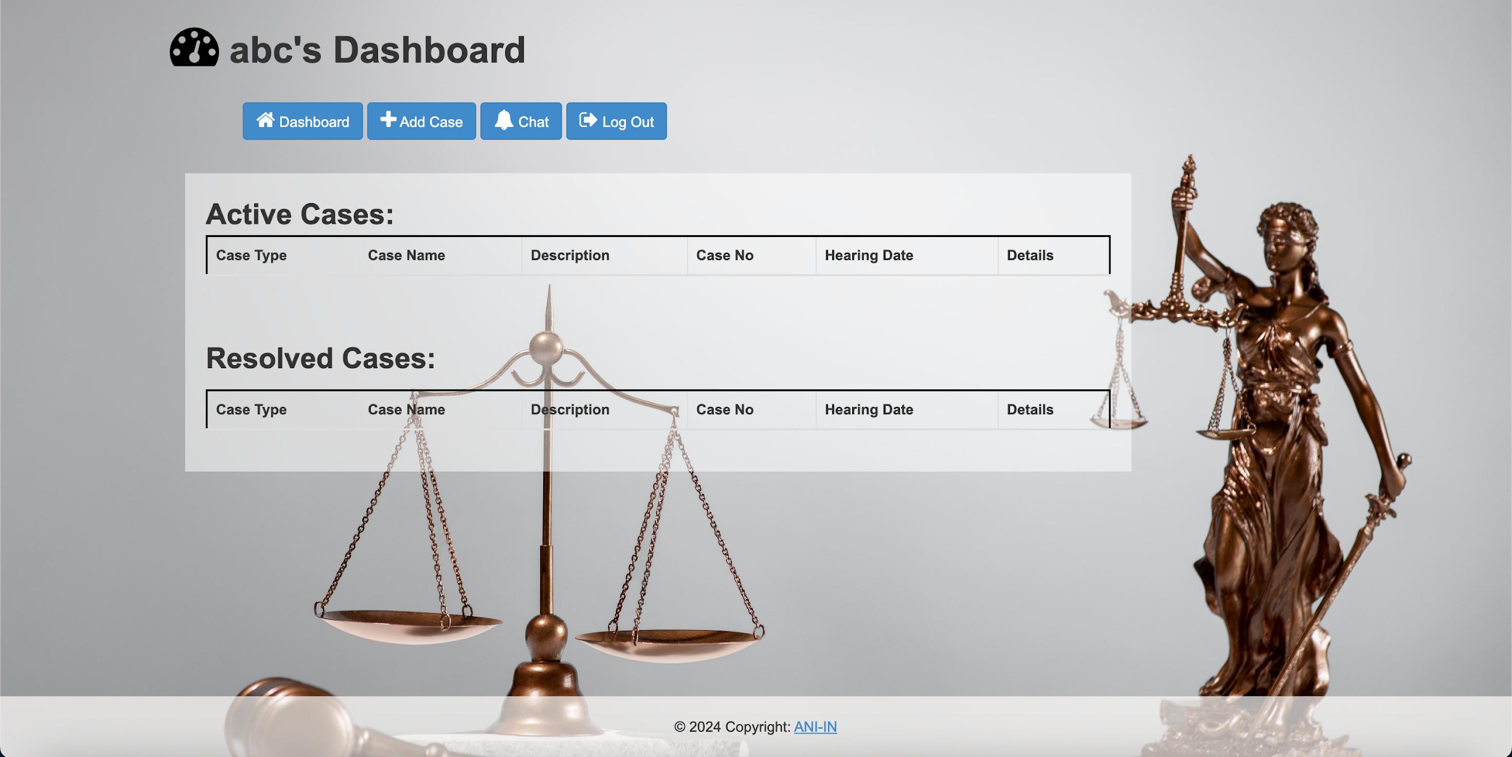

**Fig 7.4 Dashboard**

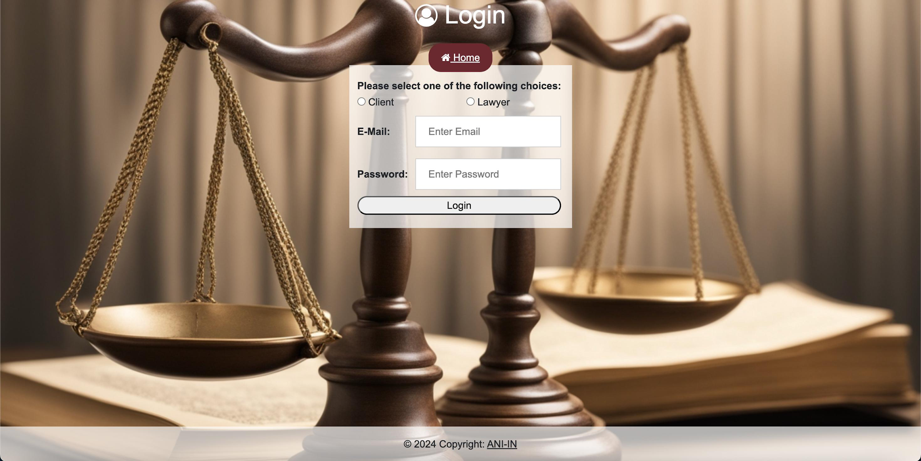

**Fig 7.5 Login Page**

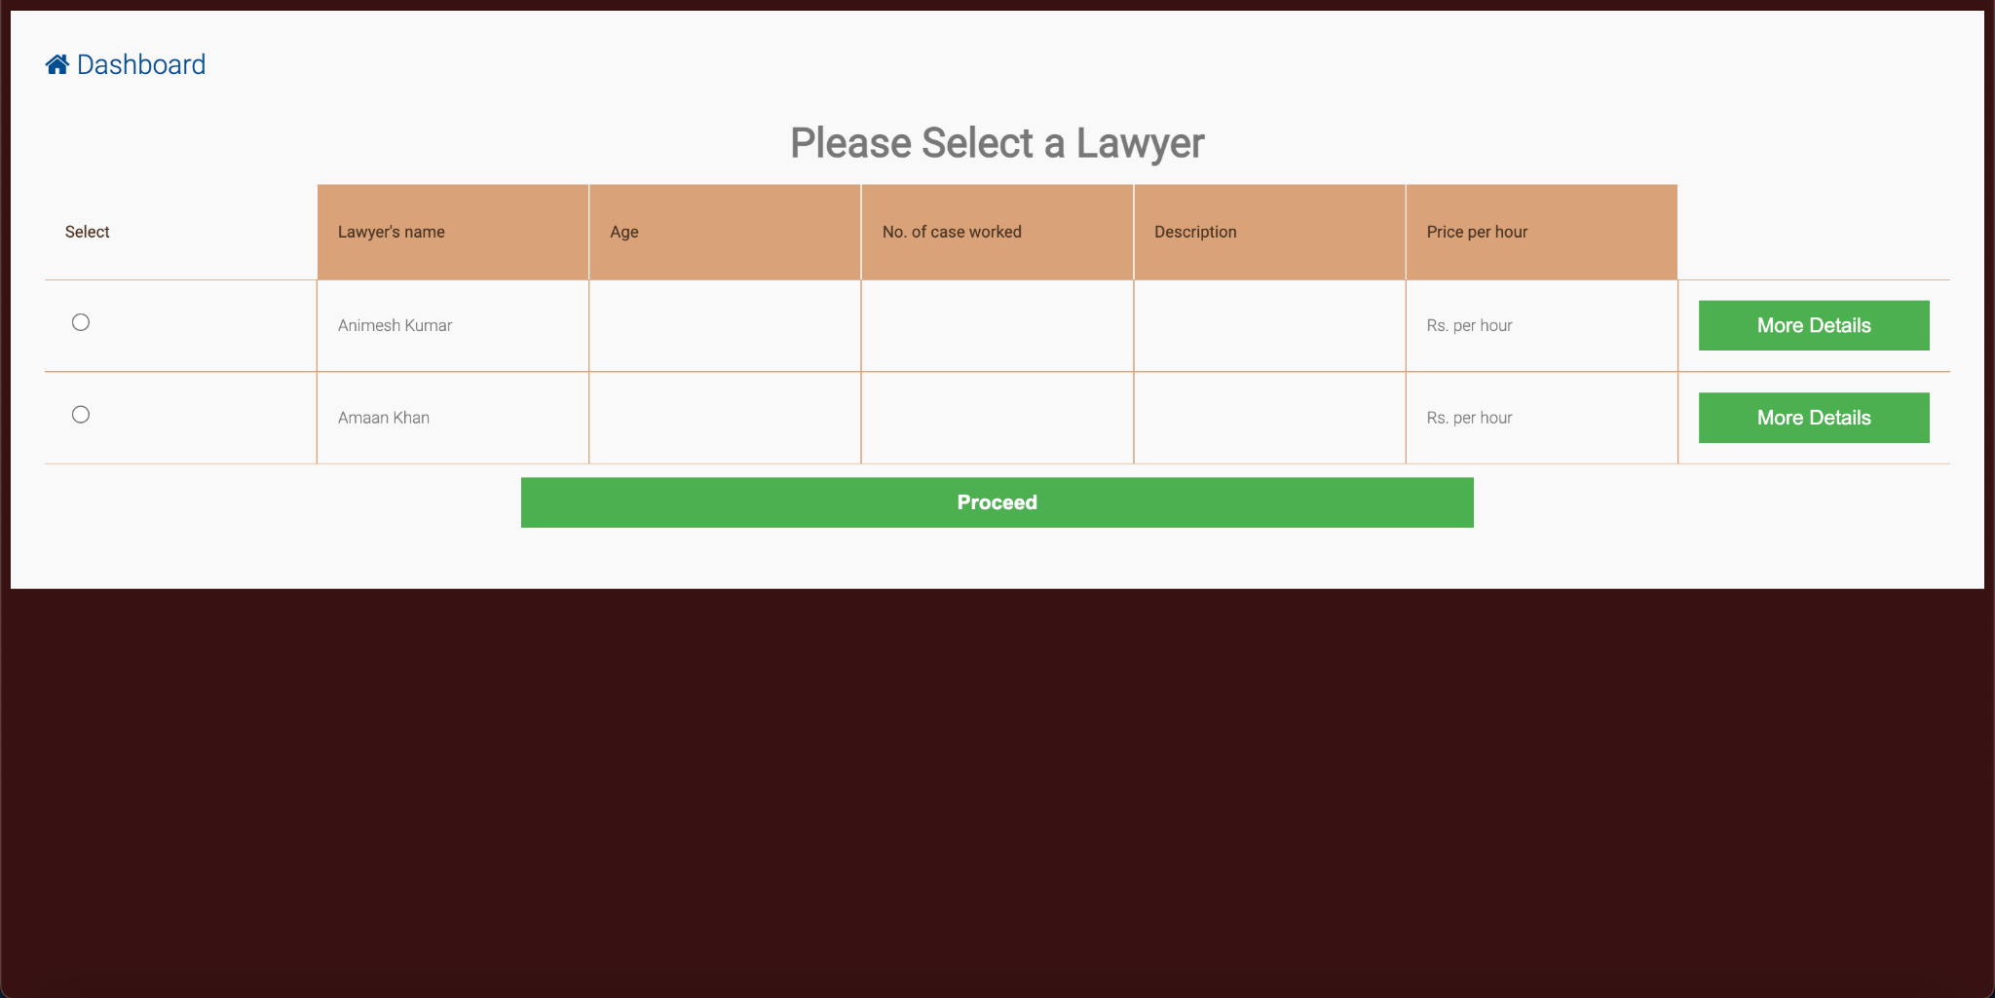

**Fig 7.6 Lawyer Selection Page**

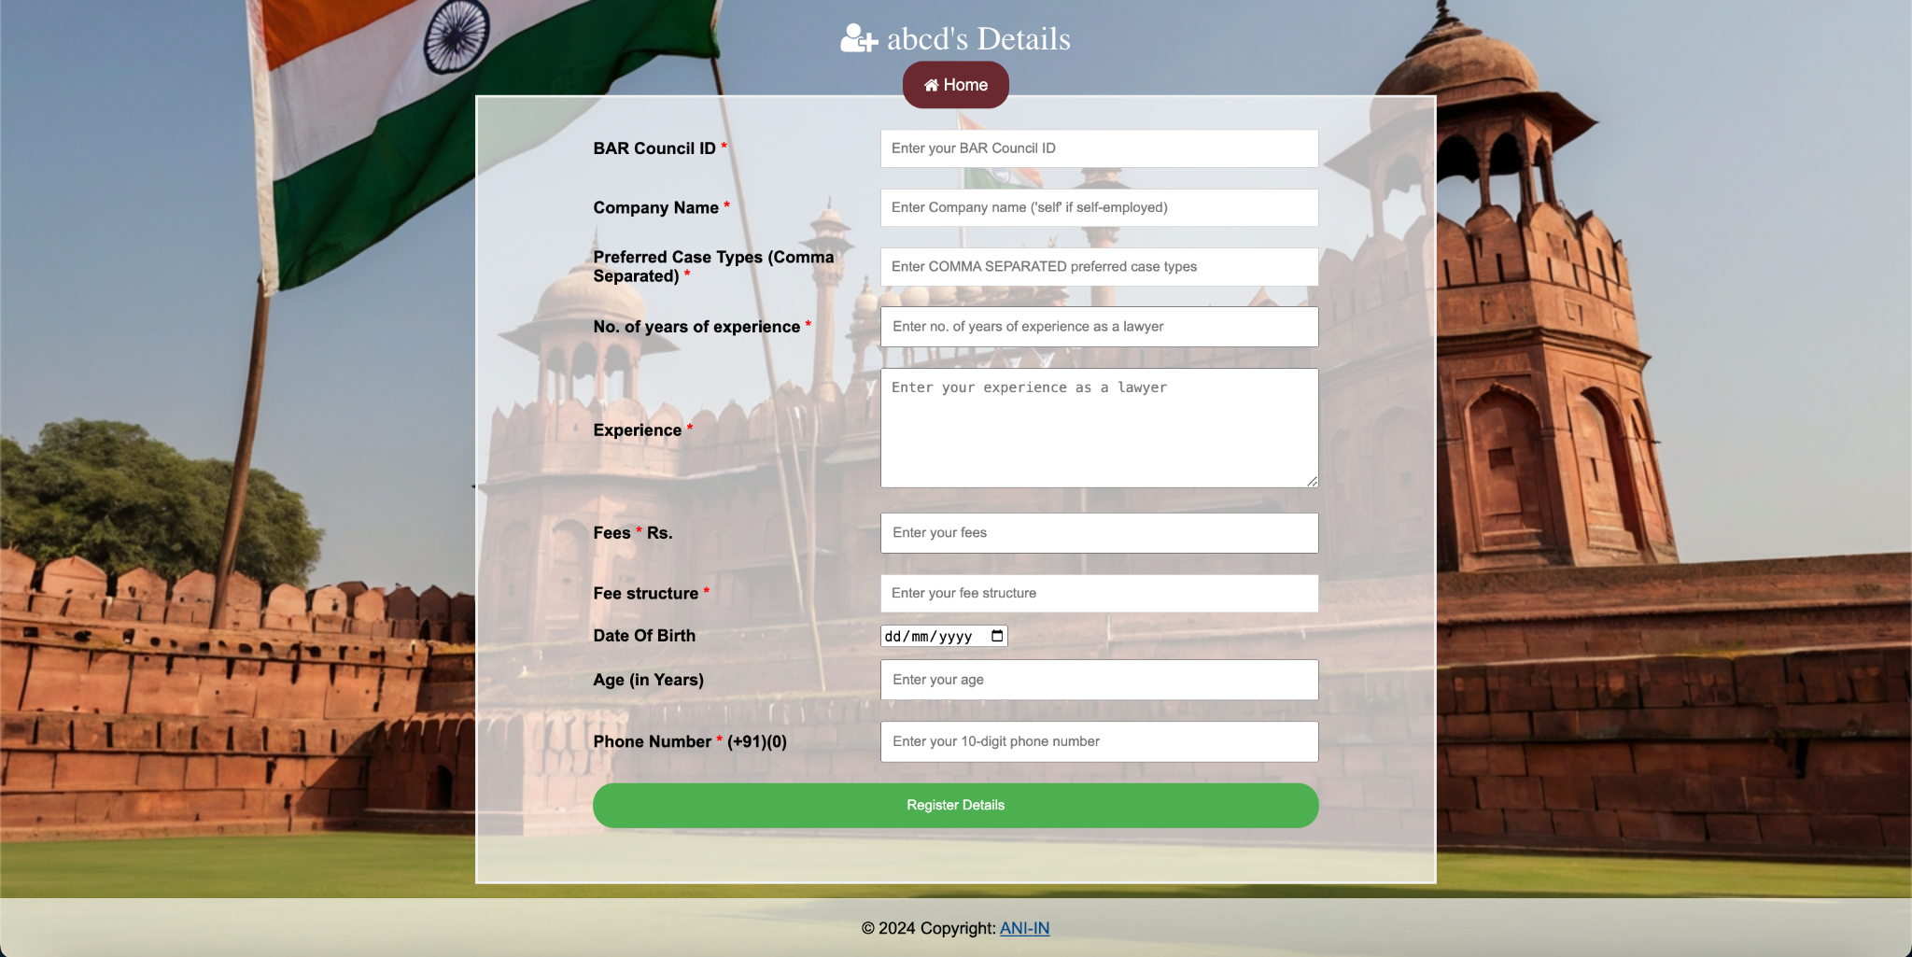

**Fig 7.7 Lawyer Details Form**

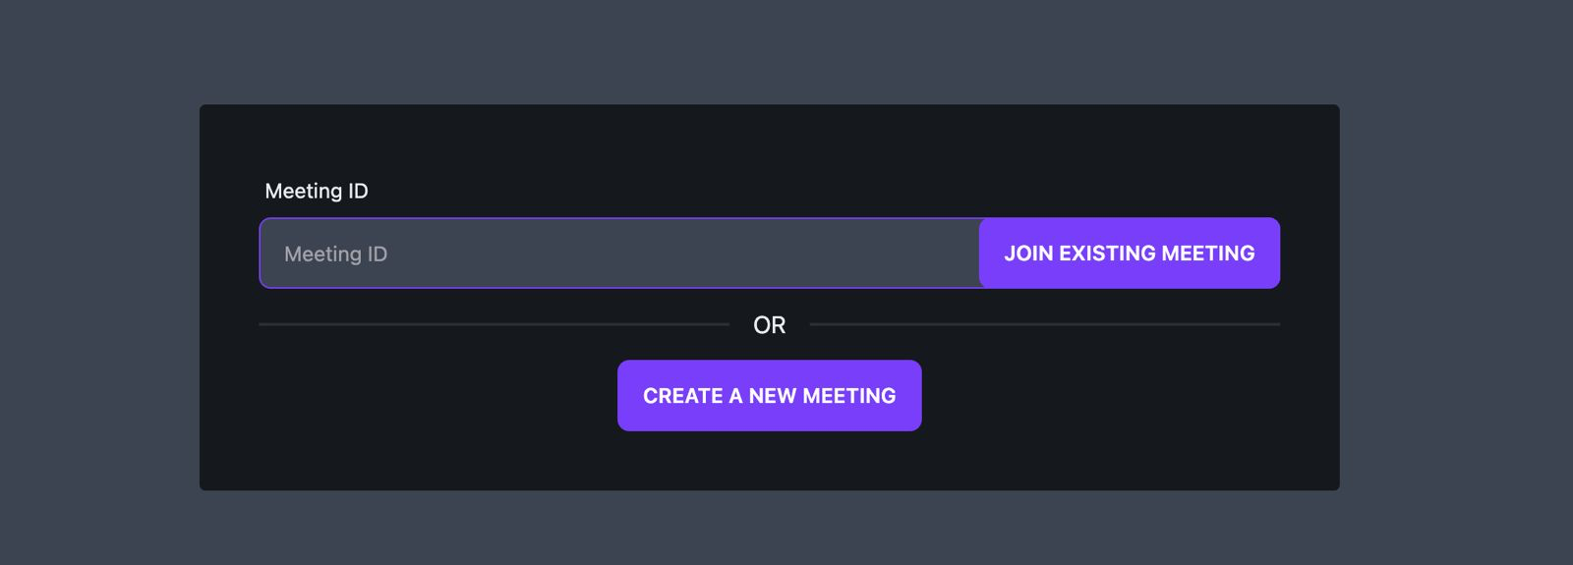

**7.8 Random Video Conference Link Generation**

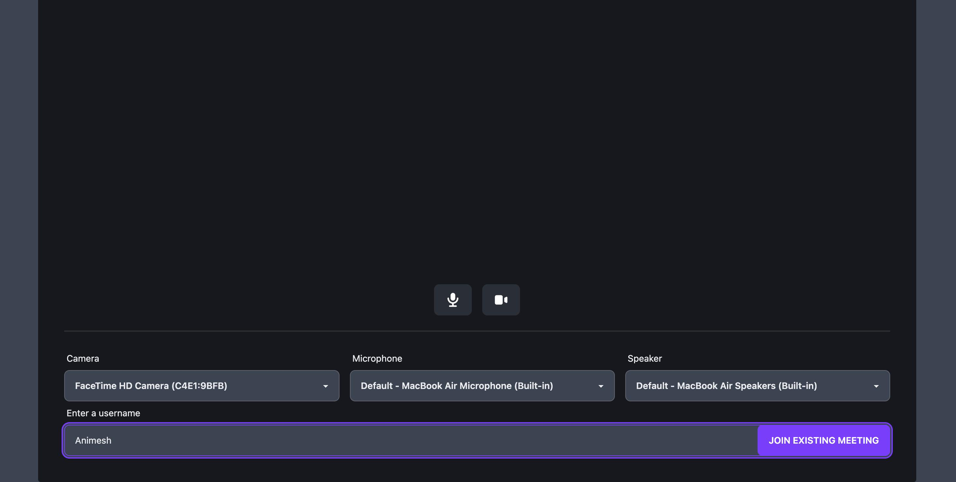

**7.9 Video Conferencing**

**Chapter 8**

**Conclusion**

**8.1 Conclusion**

The e-court system developed in this project successfully leverages cloud computing and advanced technologies to transform and modernize the legal system. By providing a centralized digital platform, the system streamlines case management processes, enhances accessibility, and improves the efficiency of the judicial system.

The system offers user-friendly interfaces for different user roles, including lawyers, clients, court staff, and judges. It enables seamless case filing, document management, and real-time tracking of case progress. Virtual hearings and online meetings facilitate remote participation, reducing the need for physical presence in court.

Furthermore, the system implements strict data security measures to protect sensitive information and ensure compliance with legal privacy laws. User data, case documents, and communication within the system are encrypted and secured, fostering trust and confidence among users.

Overall, the e-court system demonstrates the potential of digital solutions in transforming and modernizing legal practices, making the judicial system more accessible, transparent, and efficient.

**Details of Research Publication:**

The details of our research publication are as follows:

Amaan Khan, Animesh Kumar, Akshat Agarwal

(**Communicated)**

**References**

[1] N. K. Kanhere and S. T. Birchfied, “Real-time incremental segmentation and tracking of vehicles at low camera angles using stable features,” *IEEE Trans. Intell. Transp. Syst*., vol. 9, no. 1, pp.148-160, March 2008 **(Example : Journal papers)**

[2] K. Onoguchi, “Moving object detection using a cross correlation between a short accumulated histogram and a long accumulated histogram”, Proc. 18th Int. Conf. on Pattern Recognition, Hong Kong, August 20 - 24, 2006, vol. 4, pp. 896 – 899 **(Example : Conference papers)**

[3] T. H. Cormen, C. E. Leiserson, R. L. Rivest and C. Stein, “Introduction to Algorithms”, 2nd ed., The MIT Press, McGraw-Hill Book Company, 2001 **(Example : Text Book/ Magazine)**

[4]Open Source Computer Vision (OpanCV) [Online]. Accessed on 21st April 2022: <http://opencv.willowgarage.com/wiki/> **(Example : Website)**

[5] Laudy Randy Amofah “ Electronic Court Case Management System (For Law Court Complex)”

[6] Architects, I., 2017. The Seven Phases of the System-Development Life Cycle. [Online]

Available at: https://www.innovativearchitects.com/KnowledgeCenter/basic-

ITsystems/system-development-life-cycle.aspx

[7] Joy FM, 2011. High court judges to be selected electronically - Chief Justice, Accra: Fifi Koomson.

[8] Martínez, A. C., 2008. E-Justice: Using Information Communication Technologies in the Court System. [Online] Available at:

https://www.google.com.gh/search?q=In+Australia+there+is+still+work+to+be+done+to integrate+ICT.+Many+courts+still+operate t independent+systems. +Currently%2C+Vic torian +courts+and+tribunals+use+11+different+ case tmanagement+systems. +Of+particu lartconcerntis

[9] ⁠Murungi, M., 2011. Judiciary commissions electronic case management system. [Online]

Available at:

<http://michaelmurungi.blogspot.com/2011/02/judiciarycommissionselectronic-case.html>

[10] poll, G., 2009. Lacking faith in judiciary: Kenyans lean toward The Hague. [Online] Available at: [www.gallup.com/poll/122051/lacking-faith-judiciarykenyans-leantowardhague.aspx](http://www.gallup.com/poll/122051/lacking-faith-judiciarykenyans-leantowardhague.aspx).

[11] Rooze, E. J., 2010. IJCA - Differentiated Use of Electronic Case Management Systems.

Available at: <http://www.iaca.ws/files/ErwinRooze-ElecCaseMgmt.pdf>

[12] Shollei, G., 2012. Transforming the judiciary.

Available at: <http://www.judiciary.go.ke/portal/crjs-speeches.html>

[13] B., L., 2002. Courts of the future' Law and Information Technology. p. 225-238.

[14] Beal, V., 2017. Entity-Relationship Diagram (model).

Available: <http://www.webopedia.com/TERM/E/entity_relationship_diagram.html>

[15] Bockweg, J. M. G. a. G., 2012. Insights to Building a Successful E-Filing Case

Management Service: U.S... International Journal For Court Administration, pp. 1-9.

[16] ⁠Chrisphine, M. K., 2012. Mbugua_Electronic case management system.pdf.

Available: http://erepository.uonbi.ac.ke/xmlui/bitstream/handle/11295/10911/Mbugua_Electronic%

20case%20management%20system.pdf?sequence=4&isAllowed=y

[17] Christian, 2009. The seven phases of the systems development life cycle.

Available at: http://petersheehan.blogspot.com/2009/01/seven-phases-of-

systemsdevelopment_11.html

[18] Dickson, O. B., 2015. The Structure and Jurisdiction of Court the Courts. [Online]

Available at: https://www.academia.edu/12694626/THE_STRUCTURE_AND_JURISDICTION_OF

THE_COURTS

[19] Essays, U., 2015. Definition Of Fact Finding Techniques Information Technology Essay.

Available at: https://www.ukessays.com/essays/information-technology/definition-

offact-finding-techniques-information-technology-essay.php